Name: Yeshaswini Venkatesha Gupta

Assignment 1

1. (Total: 15 points)This exercise involves the Auto data set. Make sure that the missing values have been removed from the data.
2. (2 points) Which of the predictors are quantitative, and which are qualitative?

Ans: quantitative: mpg, cylinders, displacement, horsepower, weight, acceleration, year

qualitative: origin, name

1. What is the range (e.g., minimum and maximum) of each quantitative predictor?

Ans: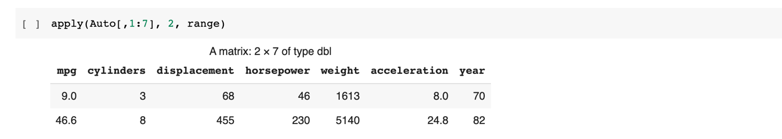

1. What is the mean and standard deviation of each quantitative predictor?

Ans:

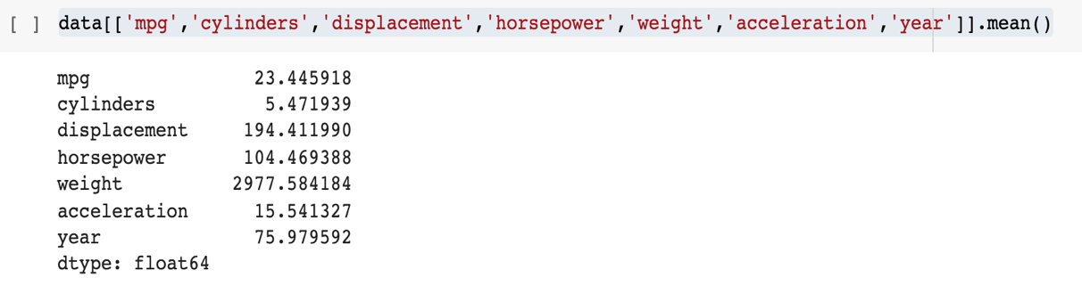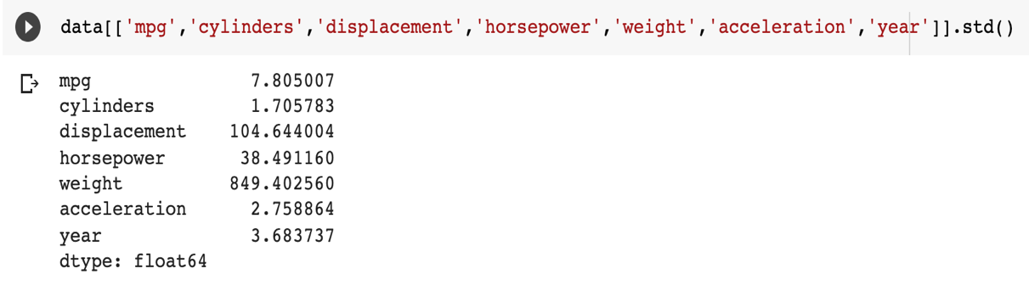

1. Now remove the 10th through 85th observations. What is the range, mean, and standard deviation of each predictor in the subset that remains?

Ans: 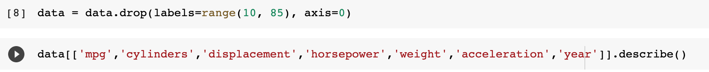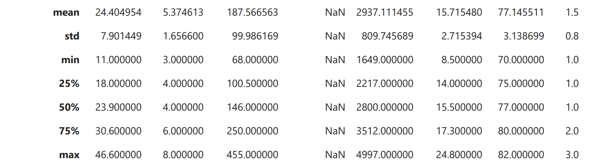

1. Using the full data set, investigate the predictors graphically, using scatterplots or other tools of your choice. Create some plots highlighting the relationships among the predictors. Comment on your findings.

Ans: It has both linear and non-linear relationships. For example, year and mpg tend to have a linear relationship whereas horsepower and mpg tend to have a non-linear relationship.



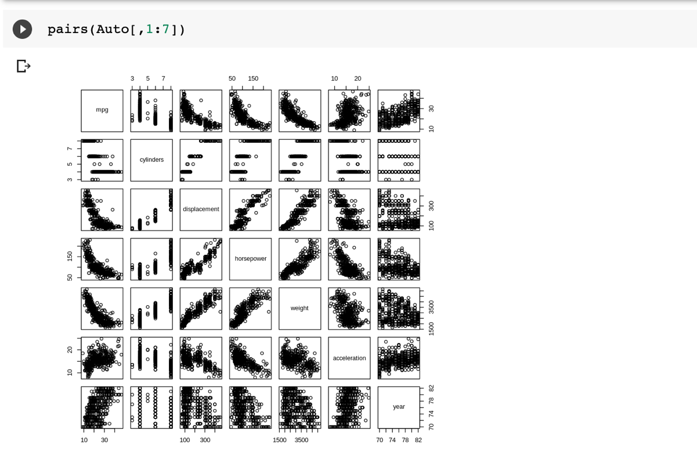

1. Suppose that we wish to predict gas mileage (mpg) on the basis of the other variables. Do your plots suggest that any of the other variables might be useful in predicting mpg? Justify your answer.

Ans: Yes, we see variables with both positive and negative relationships to the mpg result. For instance: year and mpg tend to have a positive relationship whereas horsepower and mpg tend to have a negative relationship.

1. (Total: 20 points) This exercise involves the Boston housing data set.
2. How many rows are in this data set? How many columns? What do the rows and columns represent?

Ans: No. of rows: 506

No. of columns: 14

Each row represent the set of predictor observations for a given Neighborhood in Boston. Each column represent each predictor variable for which an observation was made in 506 neighborhoods of Boston.

1. Make some pairwise scatterplots of the predictors (columns) in this data set. Describe your findings:

Ans: 

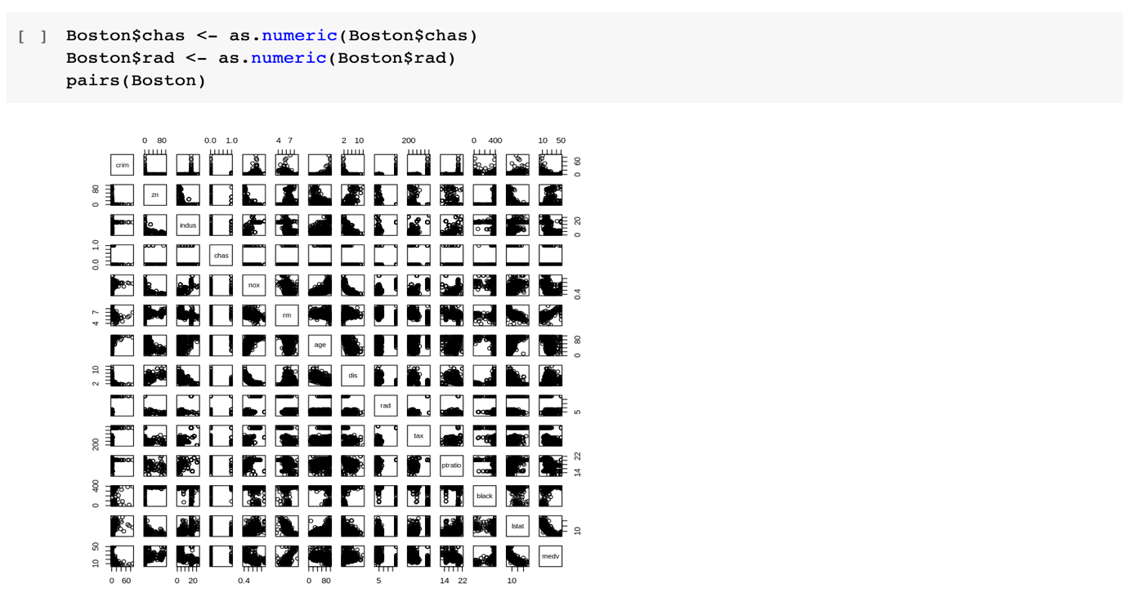

Not much can be discerned other than the fact that some variables appear to be correlated.

1. Are any of the predictors associated with per capita crime rate? If so, explain the relationship.

Ans: Based on the correlation coefficients and their corresponding p-values, there is indeed an association between the crime rate (crim) and the other predictors.

1. Do any of the suburbs of Boston appear to have particularly high crime rates? Tax rates? Pupil-teacher ratios? Comment on the range of each predictor.

Ans:

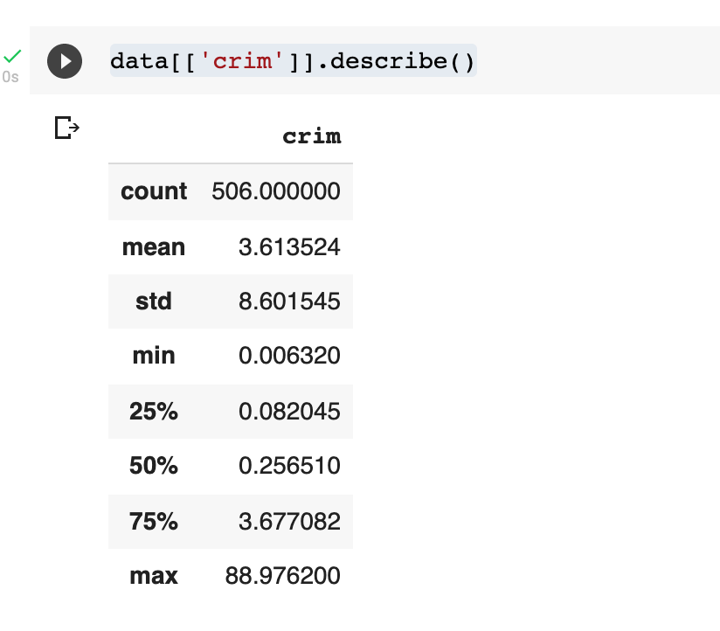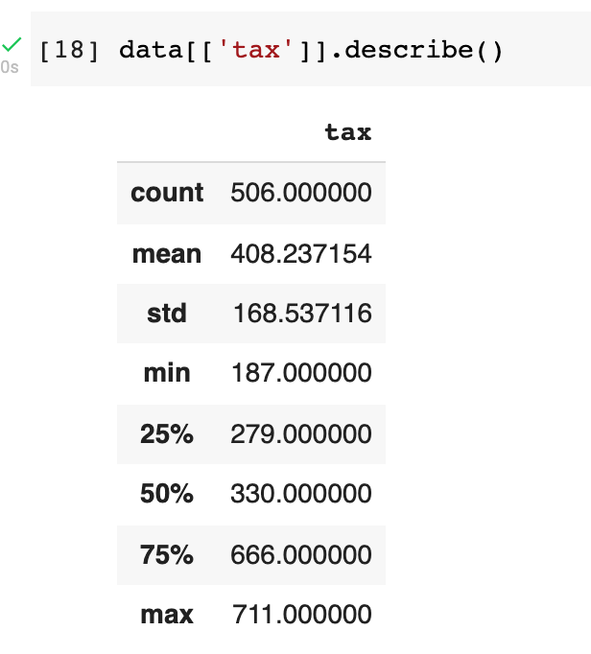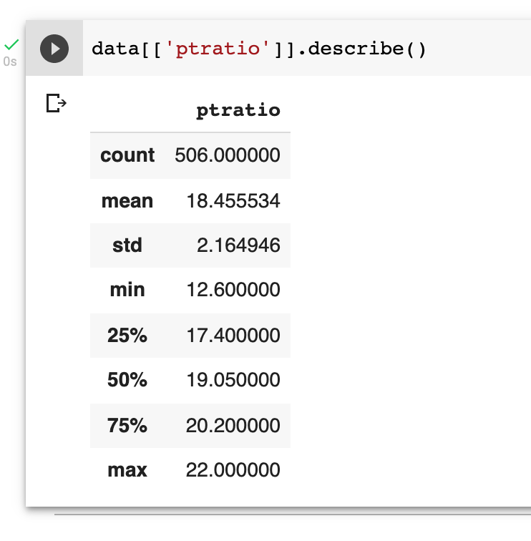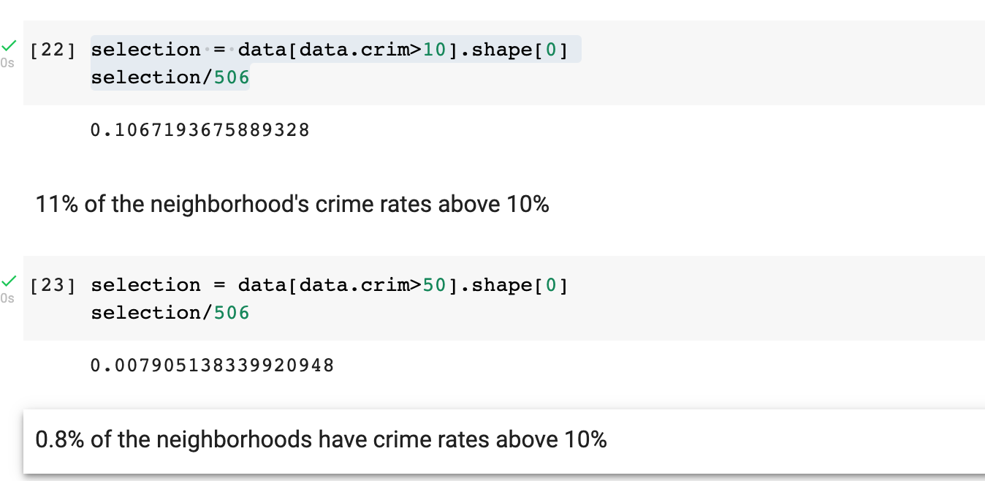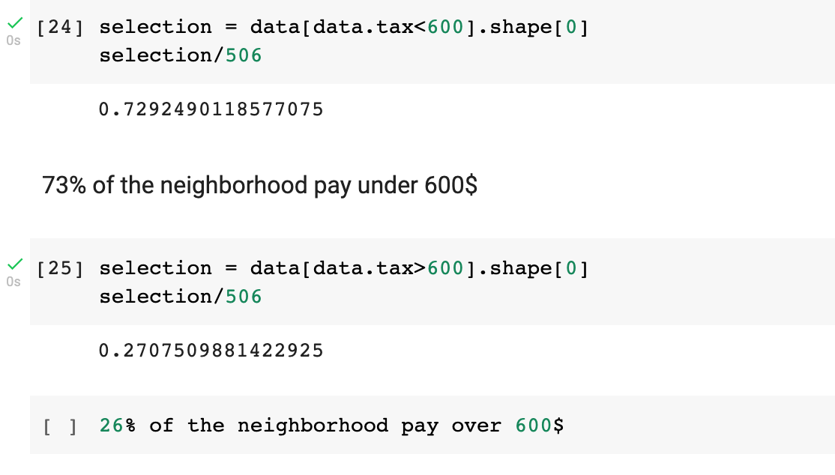

* Considering the median and maximum crime rate value which are 0.26% and 89% . There are few neighborhoods where crime rates are very high.
* Based on the scatter plot there are few neighborhood where the tax rates are higher. The median and average tax amount are $330 and $408.20

1. How many of the suburbs in this data set bound the Charles river?

Ans: 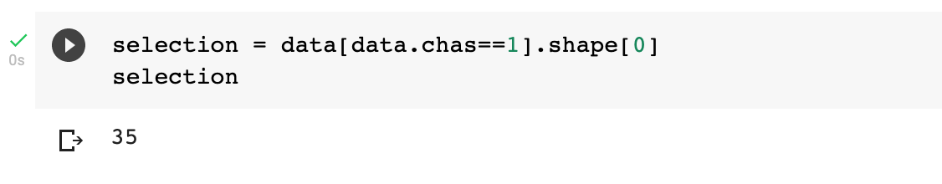

35 datasets

1. What is the median pupil-teacher ratio among the towns in this data set?

Ans: 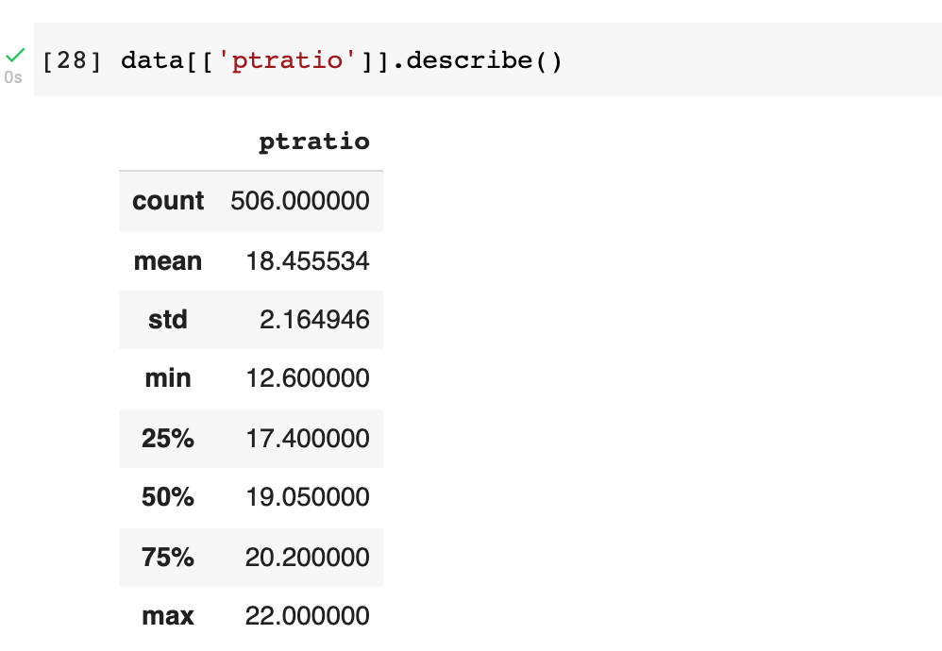

Median = 19.05

1. Which suburb of Boston has lowest median value of owner occupied homes? What are the values of the other predictors for that suburb, and how do those values compare to the overall ranges for those predictors?

Ans: 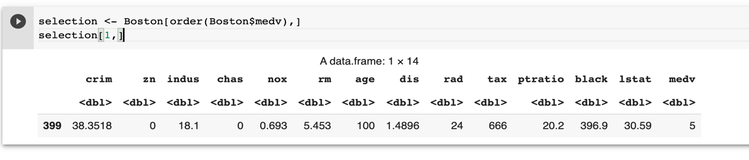

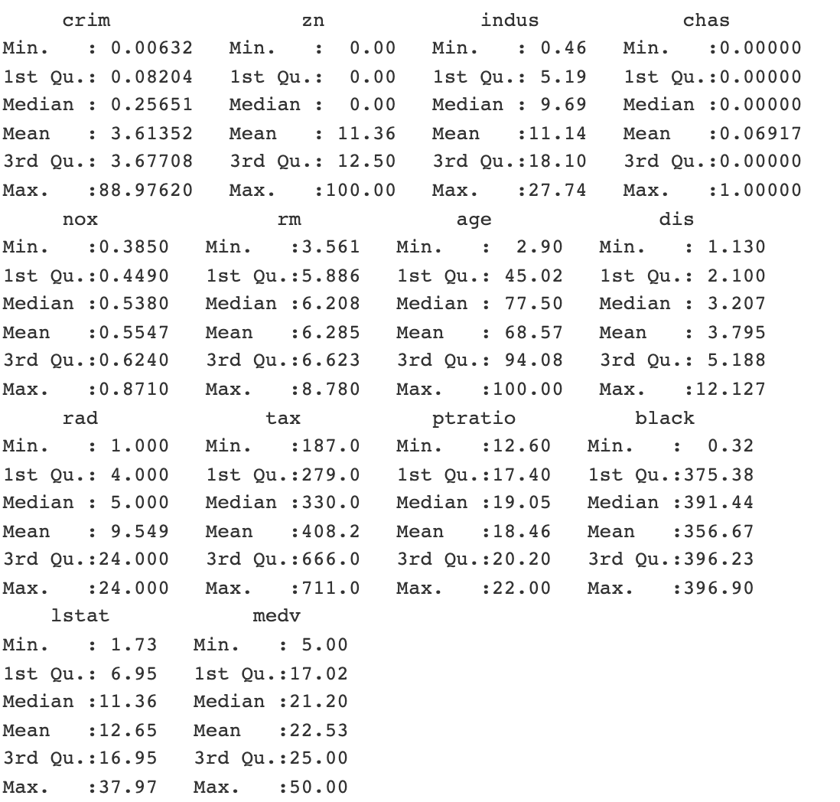

Suburb number **399**

* Crime is high when compared to other neighborhoods.
* Non-retail business acres is high when compared to most suburbs.
* This is one of the suburb that does not bound the Charles river.
* Nitrogen concentration is one of the highest.
* Average number of rooms per dwelling is lowest.
* Lowest weighted mean of distances to five Boston employment centers.
* Highest full value property tax.
* Highest pupil teacher ratio by town.

1. In this data set, how many of the suburbs average more than seven rooms per dwelling? More than eight rooms per dwelling? Comment on the suburbs that average more than eight rooms per dwelling.

Ans: 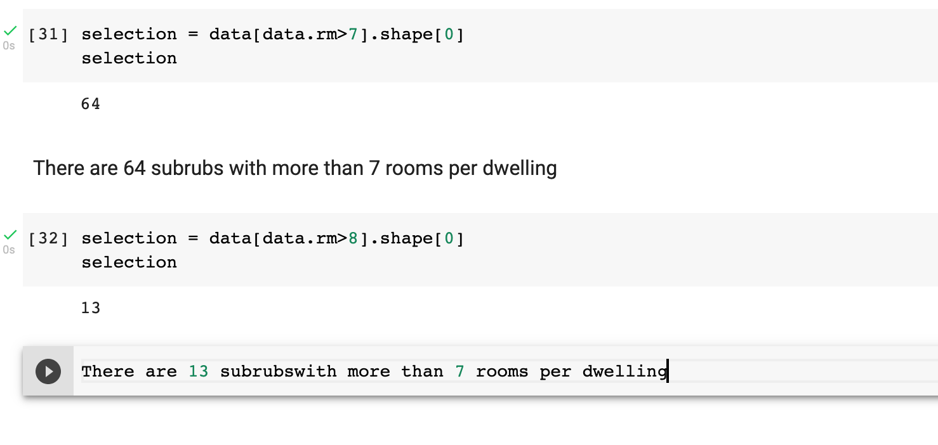

1. (Total: 24 points)In this question, you should use the Carseats data set to predict the sales in a new store with Price=$120,Advertising=$10000, ShelveLoc = Good, ’Urban=Yes, US=Yes.
2. Fit a multiple regression model to predict Sales using Price, Advertising Urban, and US. Write out the model in equation form, being careful to handle the qualitative variables properly.

Ans: Model in Equation Form Since we know general equation is described as:

hβ(x) = β0 + β1x

In this case, Price=120, Advertising =10000, ShelveLoc = Good, Urban=Yes, US=Yes. The model can be written as follows: Sales = 13.0113 + -0.0546 * Price + 0.1203 * Advertising + -0.0388 * Urban_Yes+ 0.0585 * US_Yes the corresponding values:

Sales = 13.0113 + (-0.0546 * 120) + (0.1203 * 1) + (-0.0388 * 1) + (0.0585 * 1)Sales(in thousands of units) = 6.5993

1. Provide an interpretation of each coefficient in the model. Be careful–some of the variables in the model are qualitative!

Ans: 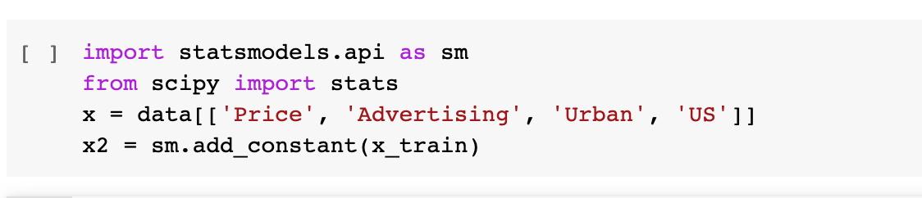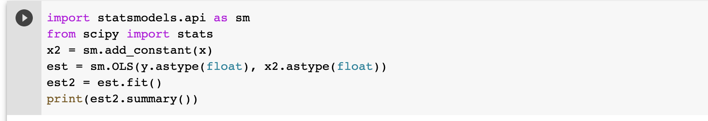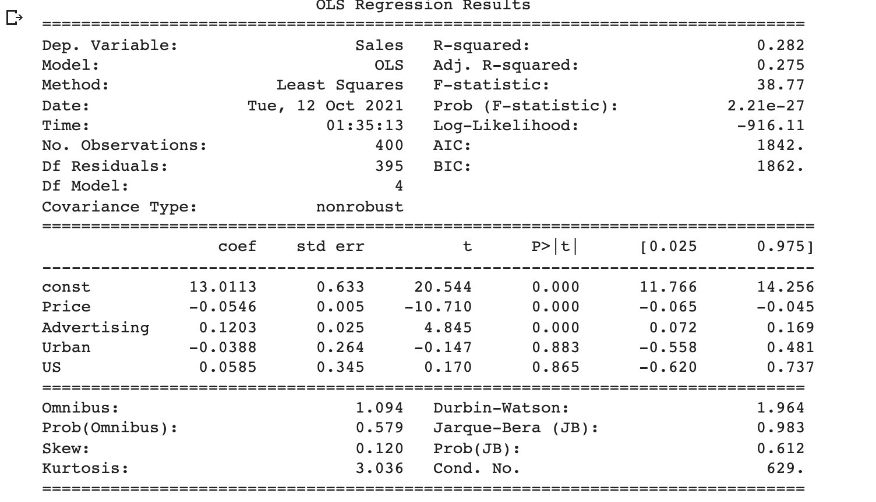

Observations:

* The coefficient related to Price is negative and increase of Price by 1 dollar will have an effect of decrease in average sales by 54.6 units.
* The coefficient related to advertising is positive and increase of Advertising budget by 1 dollar will have an effect of increase in sales by 120 units.
* The coefficient related to Urban is negative and if the store is present in urban location, it will have an effect in average sales decreasing by 38 units or we can say that the sales in urban stores are 38 units lesser than in the rural stores as an interpretation of this data.
* The coefficient related to US is positive and if the store is present in the US, it will have an effect in average by increase in 58 units.

1. Using the model from (a), predict sales in the new store and calculate 68% and 95%confidence intervals.

Ans: We know that:

68% confidence interval for β1: β^1 + SE(β^1)



95% confidence interval for β1: β^1 + 2*SE(β^1)



From (a) sales = 6.5993

Standard error = 2.4

Therefore, 68% confidence interval: 6.5993 + 2.4 = (8.9993, 4.1993)



95% confidence interval: 6.5993 + 2*2.4 = (11.3993, 1.7993)



1. Using the model from (a), what is the probability that sales will be greater than 12000units in the new store?

Ans: Probability (sales>12)=P(sales-7.682)/2.82

=P(12-7.682)/2.82

=P(sales> 2.379) = 1-P(sales<=2.379) = 0.057

Therefore there is 5.7% chance that sales will be more than 12000

1. Using the model from (a), what is the probability that sales will be between 6000 and10000 units in the new store?

Ans: Probability(6 <= sales <= 10)

=P(6-7.682)/2.82<= P(sales-7.682)/2.82 <= P(10-7.682)/2.82

= 0.4325 <= P <= 0.2061

=0.3614

Therefore 36% chance that the data will fall in between 6000 and 10000

1. For which of the predictors can you reject the null hypothesisH0:βj= 0?

Ans: If the p-value(p>|t|) is less than 0.05, we reject the null hypothesis. In this case, Urban and US have p-value greater than 0.05 and the null hypothesis cannot be rejected for these predictors.

For Advertising, the p-value is zero and hence the null hypothesis can be rejected.

1. On the basis of your response to the previous question, fit a smaller model that only uses the predictors for which there is evidence of association with the outcome. Using this model, predict sales in the new store and calculate 68% and 95% confidence intervals.

Ans:

68% confidence interval for β1: β^1 + SE(β^1)



95% confidence interval for β1: β^1 + 2*SE(β^1)



From (a) sales = 6.5993

Standard error = 2.4

Therefore, 68% confidence interval: 6.5993 + 2.4 = (8.9993, 4.1993)



95% confidence interval: 6.5993 + 2*2.4 = (11.3993, 1.7993)



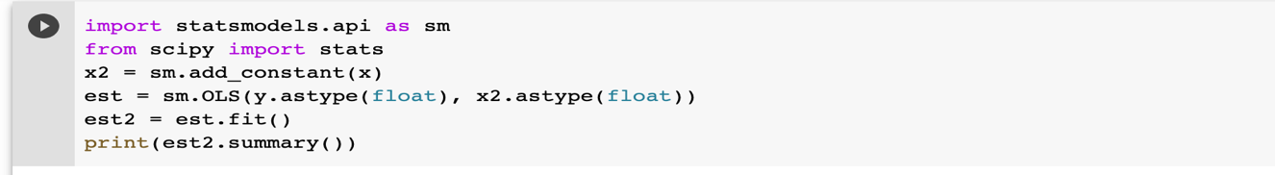

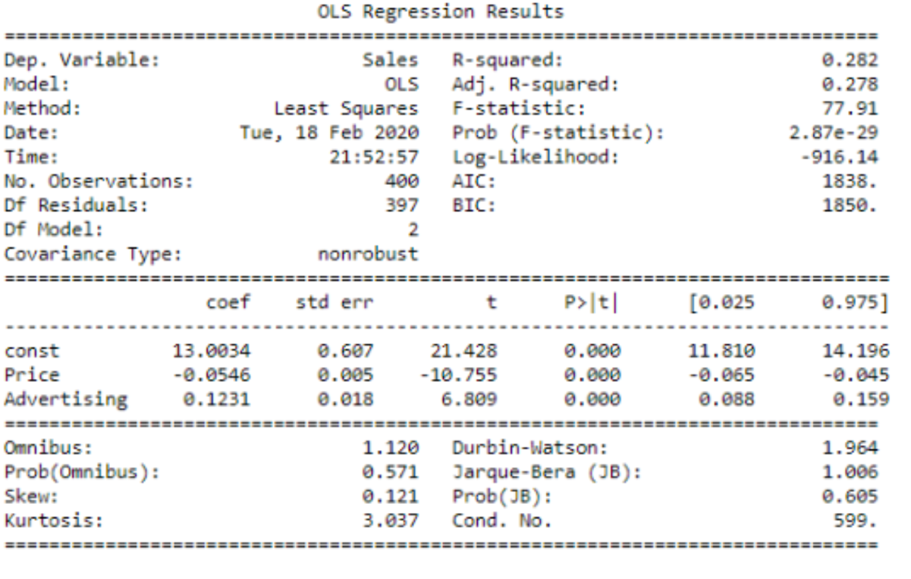

1. How well do the models in (a) and (g) fit the data?

Ans: Adjusted R-squared value compares the goodness of fit for a model and accounts for the factors that are not significant for the model. As per comparison of the two models the adjusted R-squared value of model(g) [0.275]> adjusted R-squared value of model (a) [0.278]. It seems that the first model is facing overfitting, hence the second model(g) fits the data better than (a)

1. (Total: 27 points) This problem involves the sales data set for Toyota Corolla, which can be found in the file ToyotaCorolla.csv. The data set contains 1436 observations on the following 10 variables.
2. Which of the predictors are quantitative, and which are qualitative?

Ans: **Quantitative**: Price, Age, Milage, Displacement, Doors, Weight, Horsepower

**Qualitative**: FuelType, MetColor, Automatic

1. What is the range (i.e., min and max) of each quantitative predictor?

Ans: 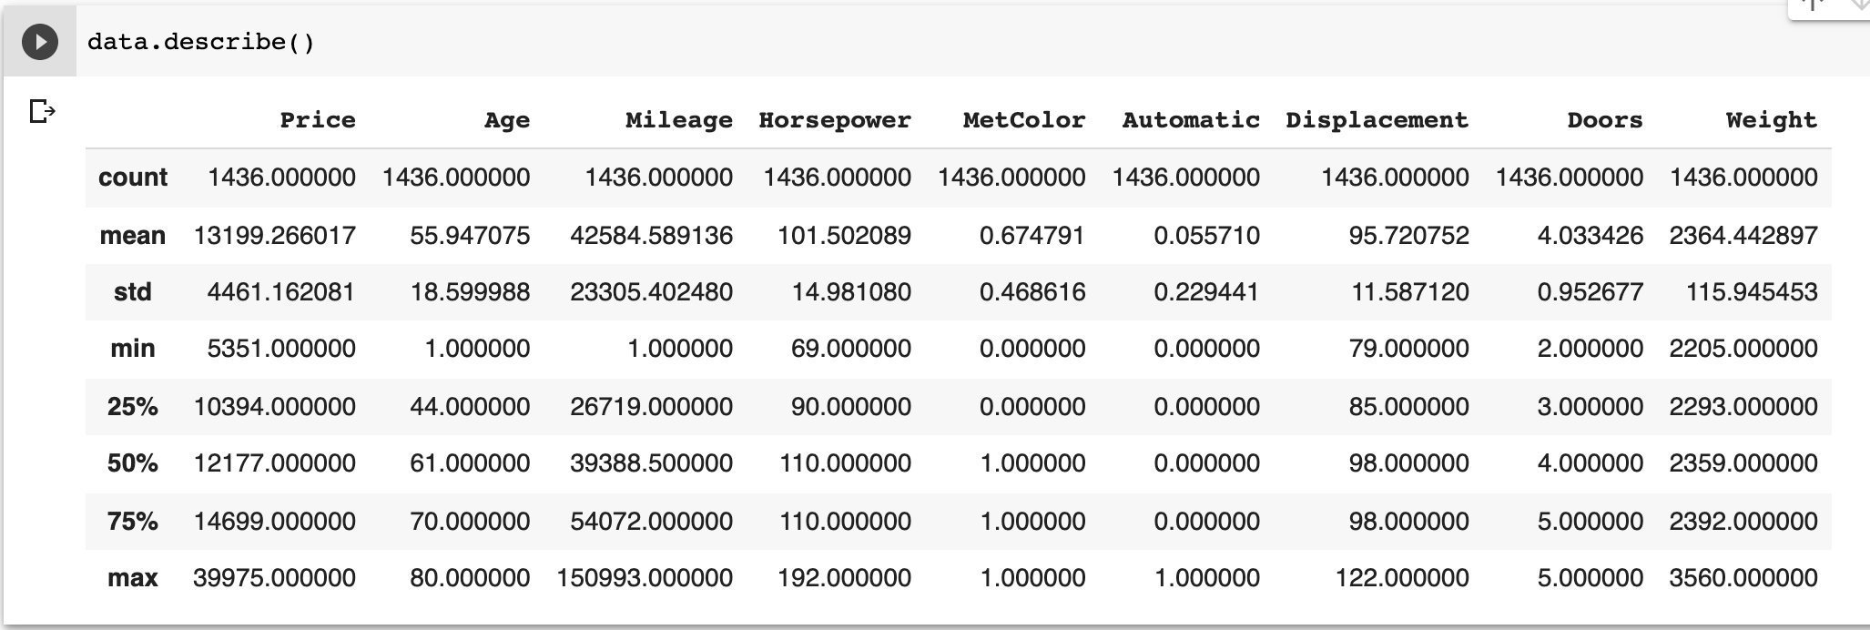

1. What is the mean and standard deviation of each quantitative predictor?

Ans: 

1. Investigate the predictors graphically, using scatterplots or other tools of your choice. Create some plots highlighting the relationships among the predictors. Comment on your findings.

Ans: 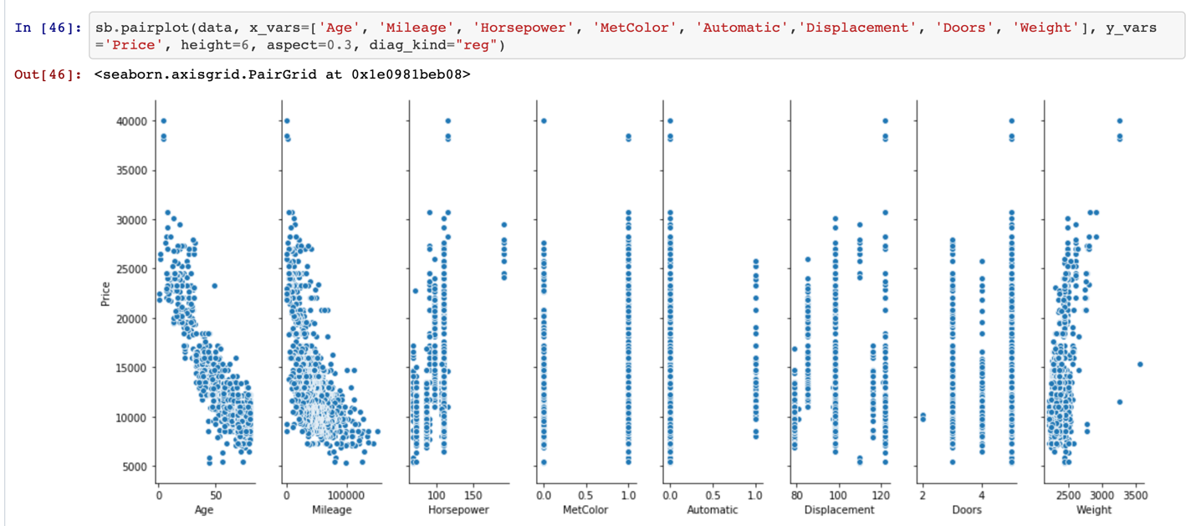

The figure above shows the pair plot with predictors such as ‘Age’, ‘Milage’, ‘Horsepower’, ‘MetColor’, ‘Automatic’, ‘Displacement’, ‘Doors’, ‘Weight’ against ‘Price’.

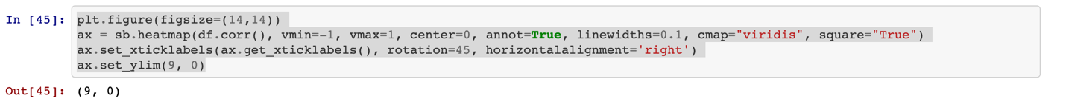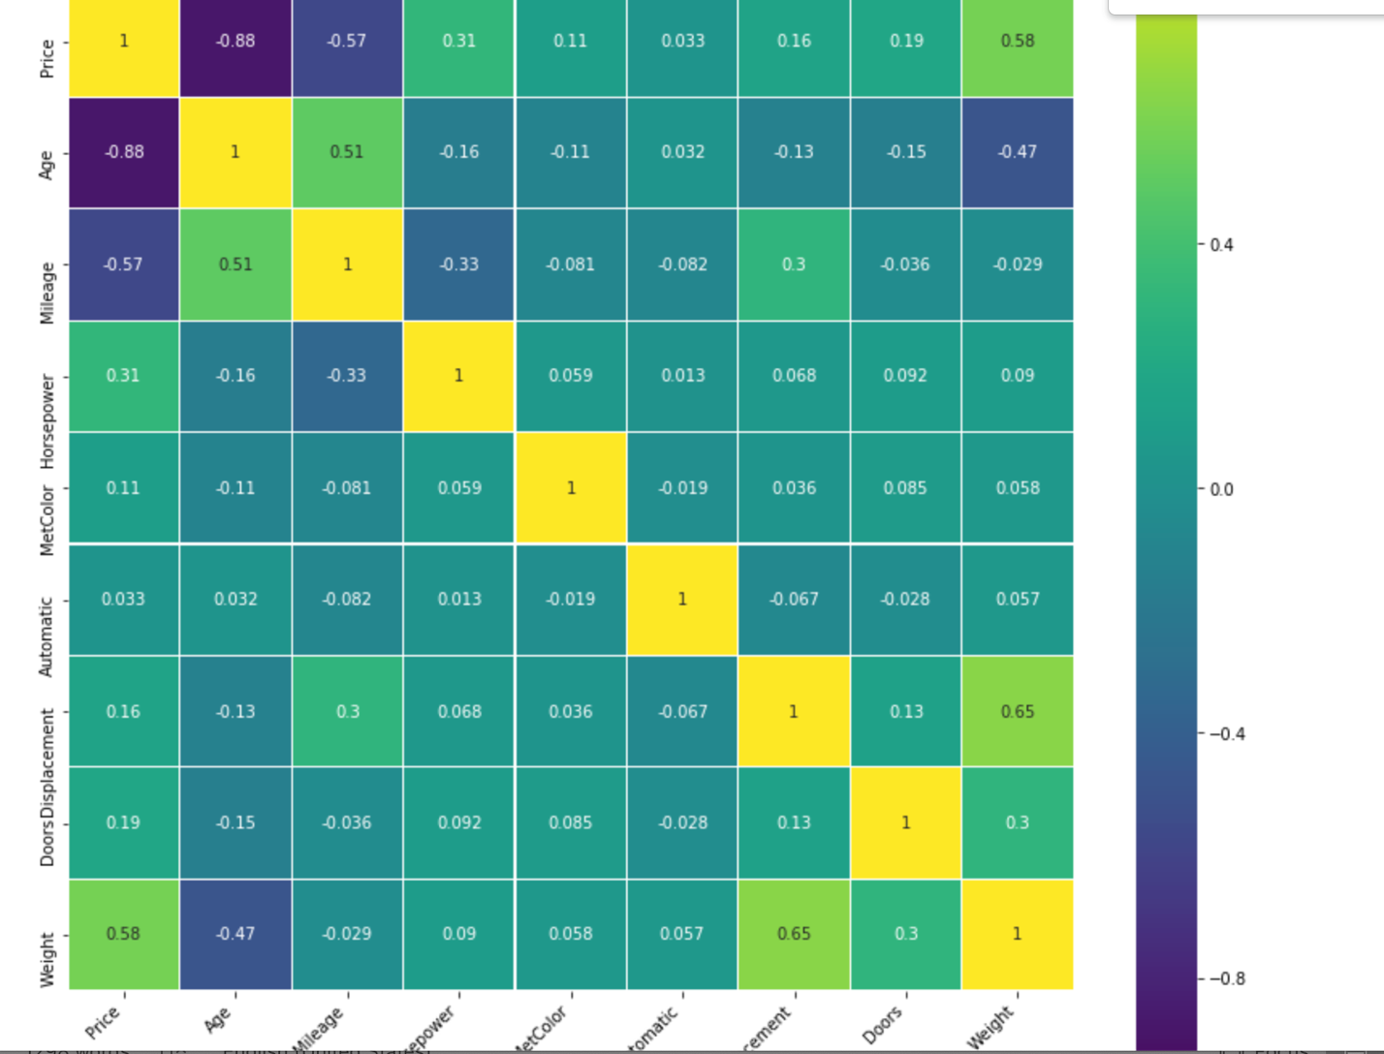

The darker shade of blue shows less correlation and the light-yellow shows high correlation, as per the heatmap light green shows slight correlation between predictors.

The correlation between factors such as age and mileage is quite significant, similar is the correlation between weight and price.

There is negative correlation between predictors such as age and price from heatmap.

The figure below shows the pair plot for the predictors with all predictors included.

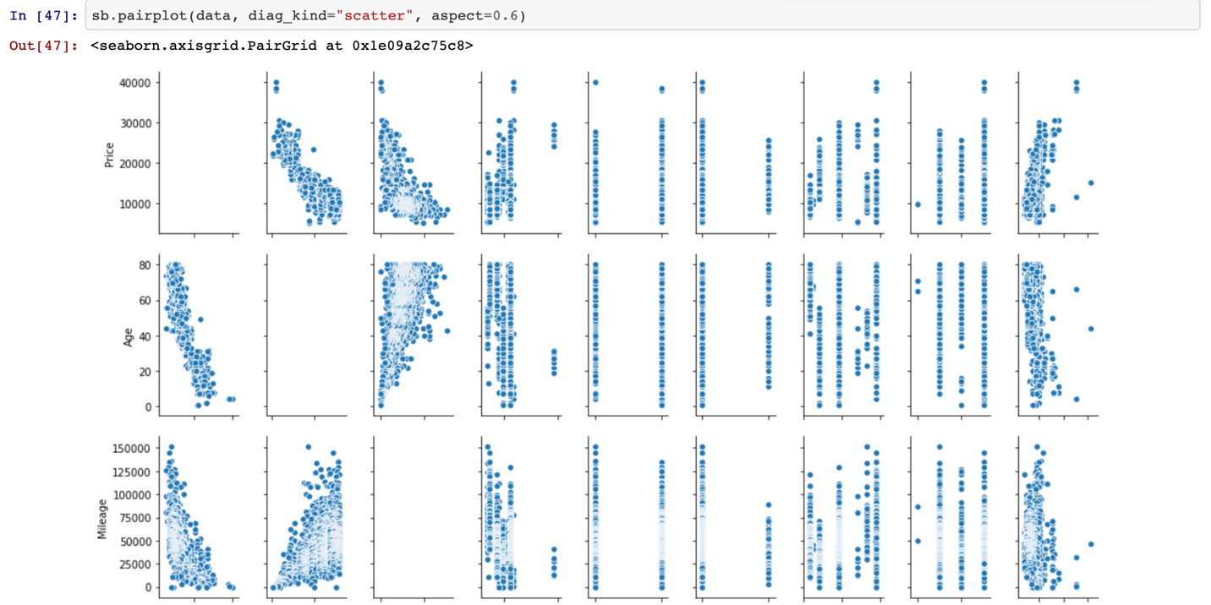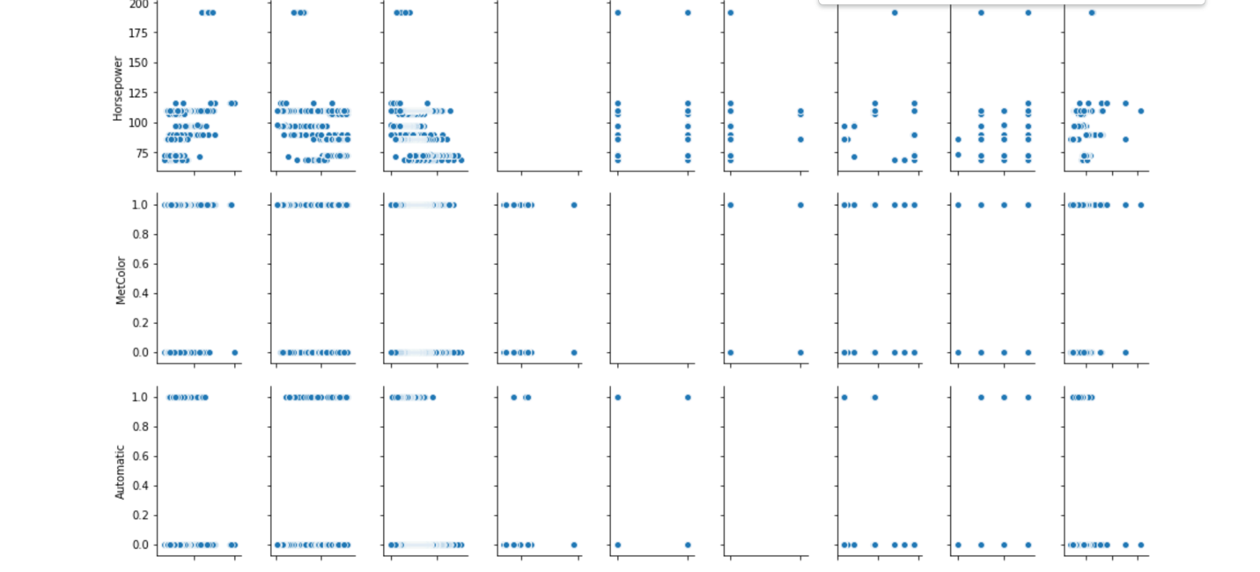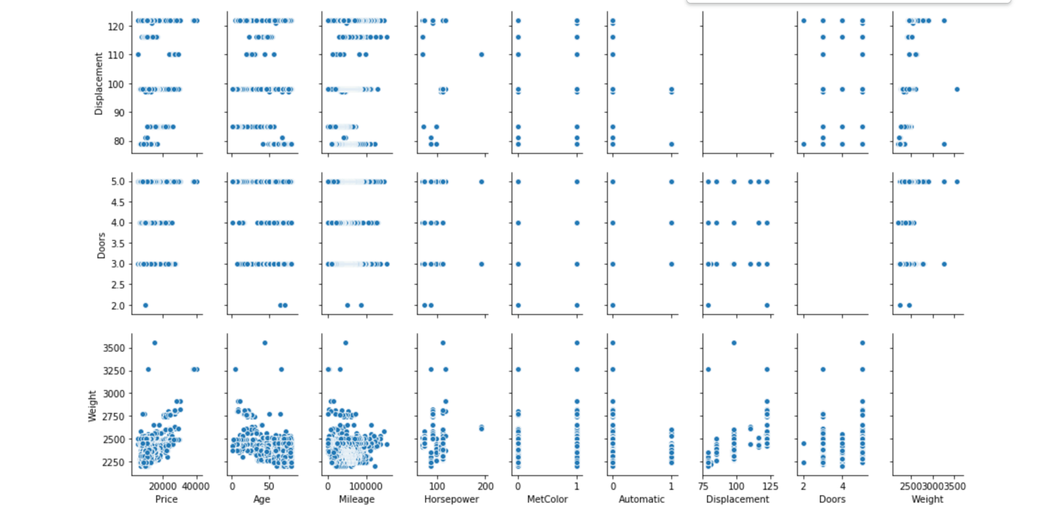

1. Suppose that we wish to predict gas mileage (mpg) on the basis of the other variables. Do your plots suggest that any of the other variables might be useful in predicting mpg? Justify your answer.

Ans: Based on the heatmap and the pair plot above it is evident that milage is directly proportional to age, higher the age, higher the milage. Horsepower or price increase result in decrease in milage.

1. Fit a simple linear regression with Price as the response and Age as the predictor.
2. Is there a relationship between the predictor and the response?

Ans: 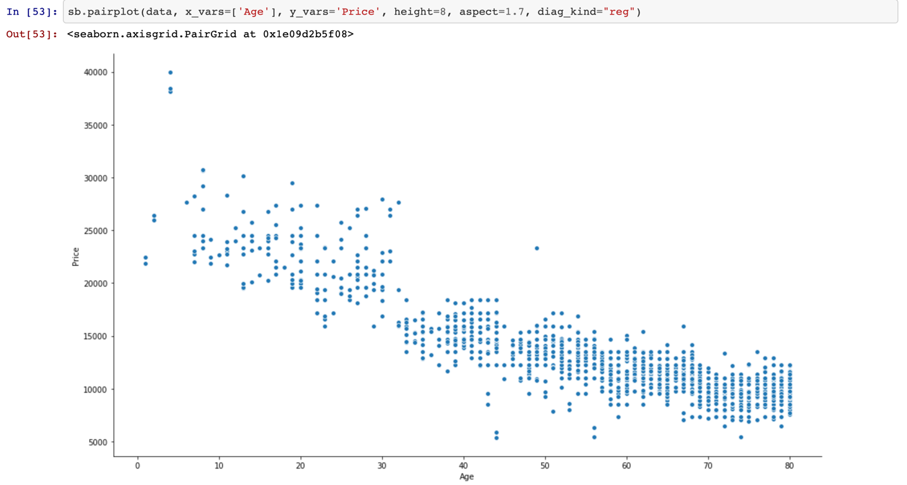

Model equation: Price = 24962 + (-210.2481*Age)

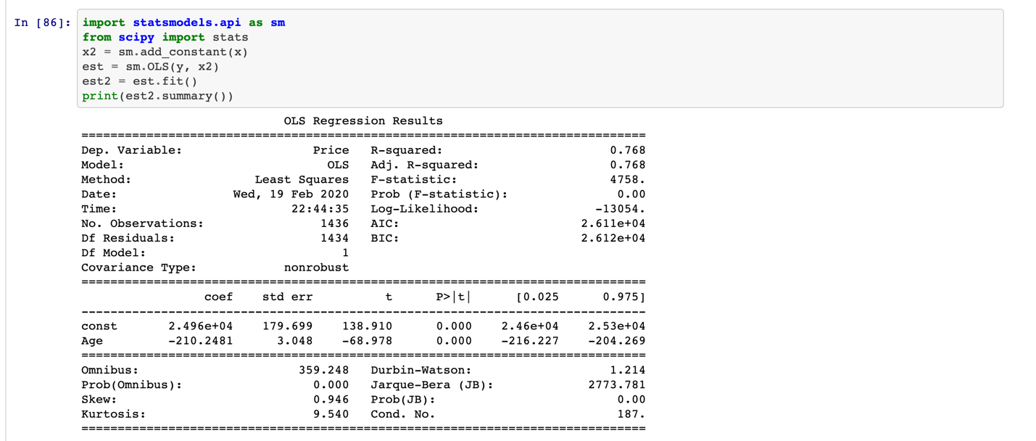

Since the p-value(p>|t|) is zero for the predictor age, the null hypothesis can be rejected, and we can observe a relationship between predictor and response.

1. How strong is the relationship between the predictor and the response?

Ans: Since R-squared is the measure of how closely the data is fitted to the regression line, in this case, the R-squared value can help reveal the strength of relationship between the predictor and response. The R-squared value is 0.768, which signifies that 76.8% of the change in price can be described by the age which is strong in comparison to other predictors.

1. What is the predicted price associated for a car with an age of 48 months? What are the associated 95% confidence intervals?

Ans: Price = 24962 + (-210.2481*Age)

Price = 24962 + (-210.2481*48)

Price = 14870.0912 in dollars

Standard Deviation: 2147

95% confidence interval: 24962 + 2*2147



1. Fit a multiple linear regression with Price as the response and all other variables the predictors.
2. Is there a relationship between the predictors and the response?

Ans: 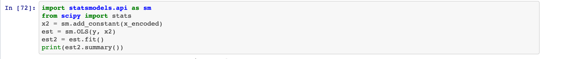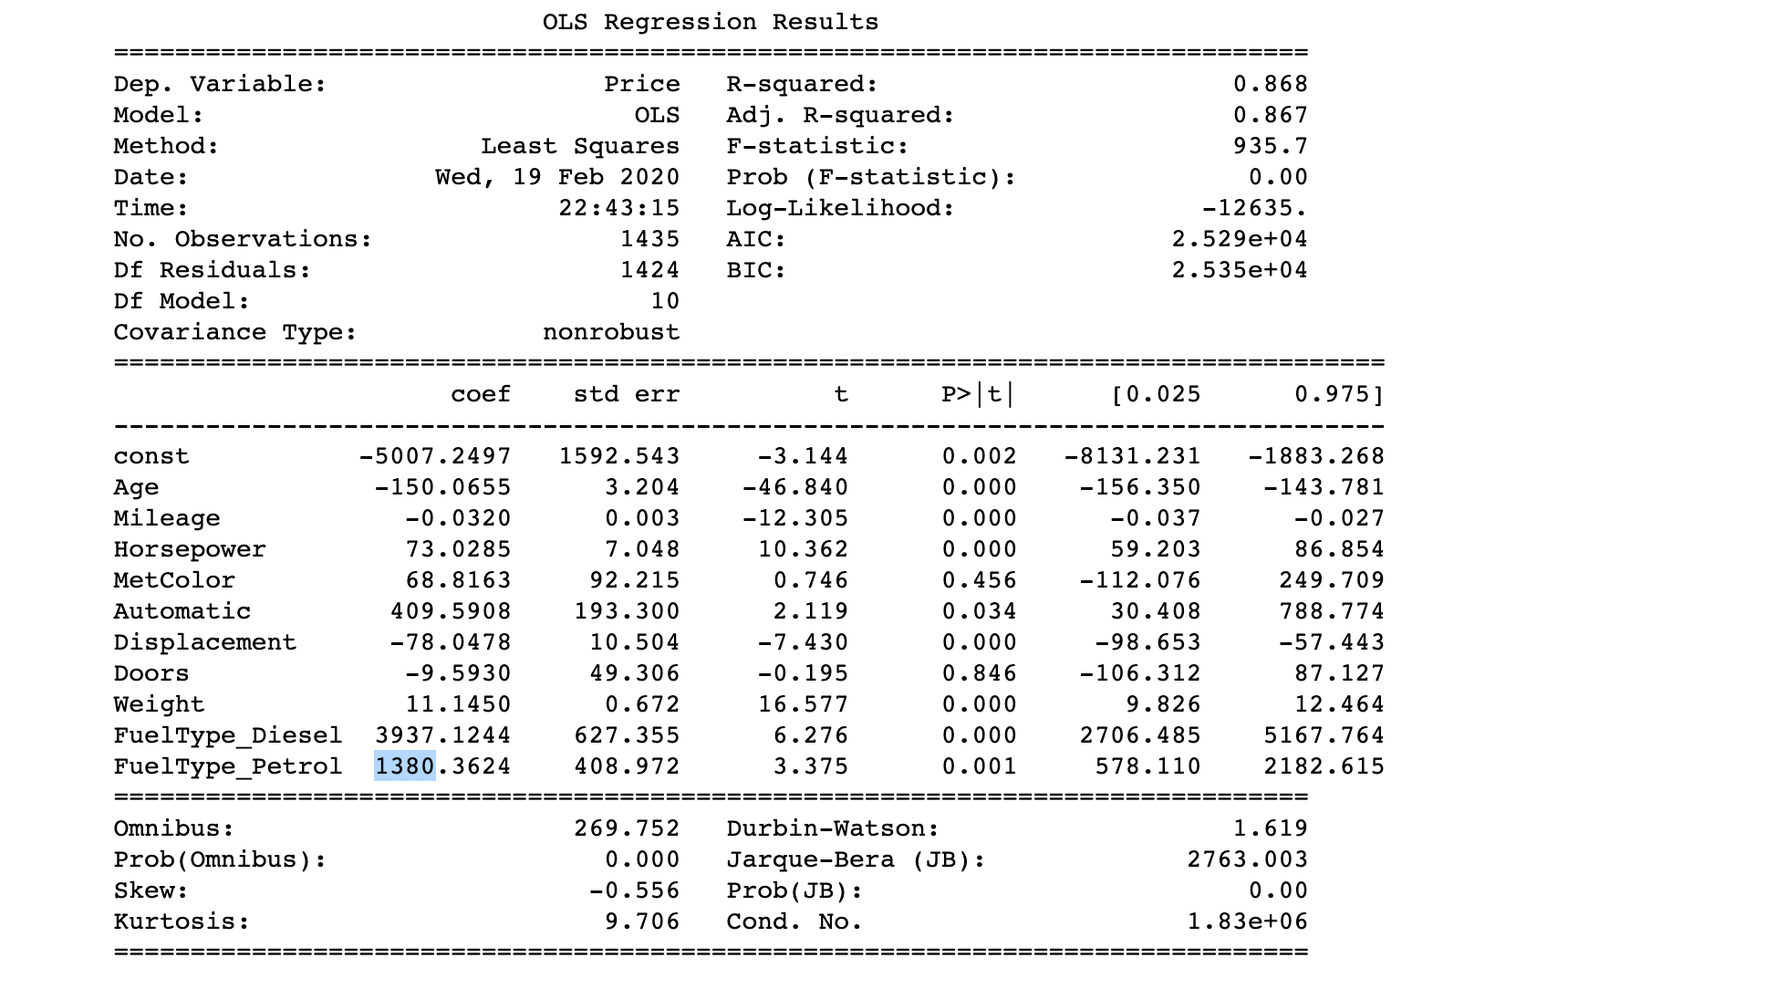

The p-value(p>|t|) is zero for all predictors except Doors and MetColor, so we can’t reject the null hypothesis for these two predictors, but all the other factors exhibit significant relationship to the response(price).

1. How strong is the relationship between the predictors and the response?

Ans: Since R-squared is the measure of how closely the data is fitted to the regression line, in this case, the R-squared value can help reveal the strength of relationship between the predictor and response. The R-squared value is 0.868, which signifies that 86.8% of the change in price can be described by the age which is strong in comparison to other predictors.

1. Which predictors appear to have a statistically significant relationship to the response?

Ans: The predictors which show significant relationship to the response are:

Age, Mileage, Horsepower, Automatic, Displacement, Weight, FuelType

1. What does the coefficient for the age variable suggest? How accurate can you estimate the effect of age on price?

Ans: 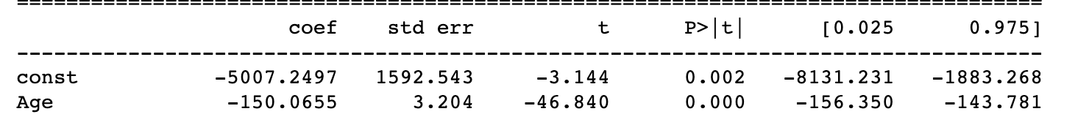

We observe that with an increase in Age by 1 month, there is a decrease in price by 150 dollars. The accuracy of the estimation can be deducted by the R-squared value, which is 0.768.

1. What is the predicted price associated for a car with a mileage of 45000 miles, 48 months, diesel, automatic transmission, 4 doors, 2568 pounds, a displacement of 122 cu. inches, a horsepowerof 90, and non-metallic color? What are the associated 95% confidence intervals?

Ans: Price =-5007.2497 + (-150.0655* Age) + (-0.0320 * Mileage) + 73.0285 * Horsepower + 68.8163 * MetColor + 409.5908 * Automatic + (-78.0478 * Displacement) + (-9.5930 * Doors) + (11.1450 * Weight) + (3937.1244 * FuelType_Diesel)

Therefore, Price = 17625.0429 dollars

Standard Deviation = 1618.8560

95% confidence interval: 17625.0429 +-2*1618.856

1. Which predictors matter most for predicting the price for a car? (Find the first and the second most important variables)

Ans: The first most important value is Age as we saw a high R-squared value for a single predictor, also observed the relation from heatmap and pair plot.

The second most important variable is Weight with a positive correlation as observed from the heatmap.

1. This problem involves the Boston data set. We want to predict per capita crime rate using the other variables in this data set. In other words, per capita crime rate is the response, and the other variables are the predictors.
2. (3 points) For each predictor, fit a simple linear regression model to predict the response. Describe your results. In which of the models is there a statistically significant association between the predictor and the response? Create some plots to back up your assertions.

Ans:

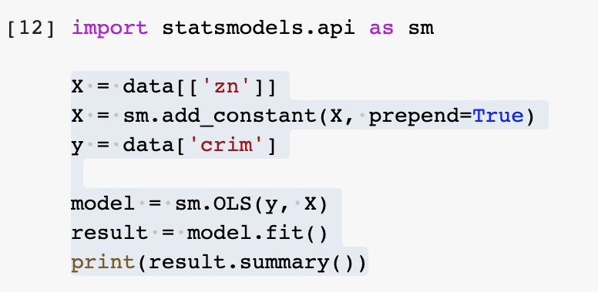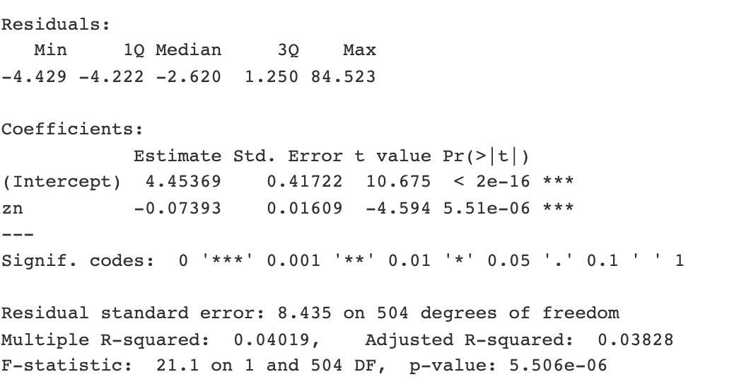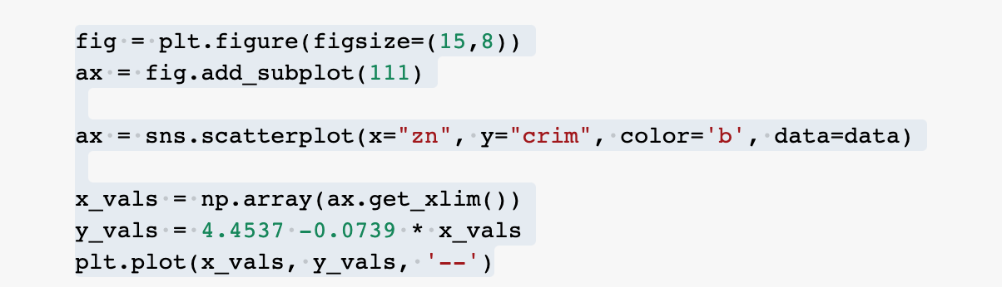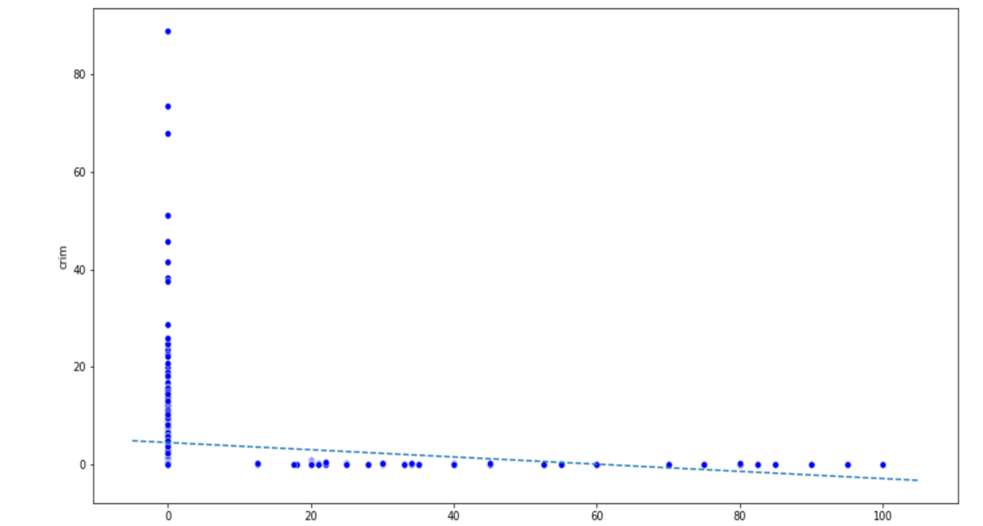

* From the above analysis, we can say that there is a low negative relationship between “crime” and “zn”

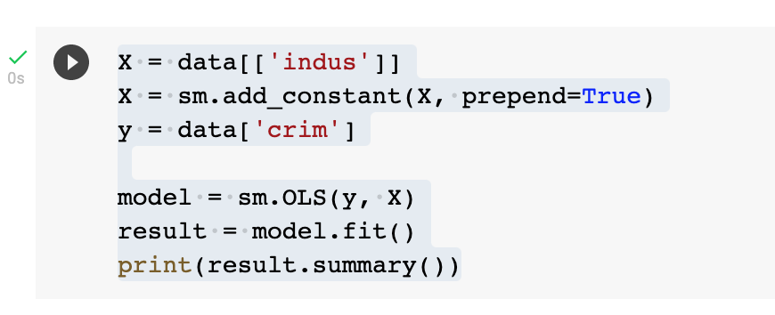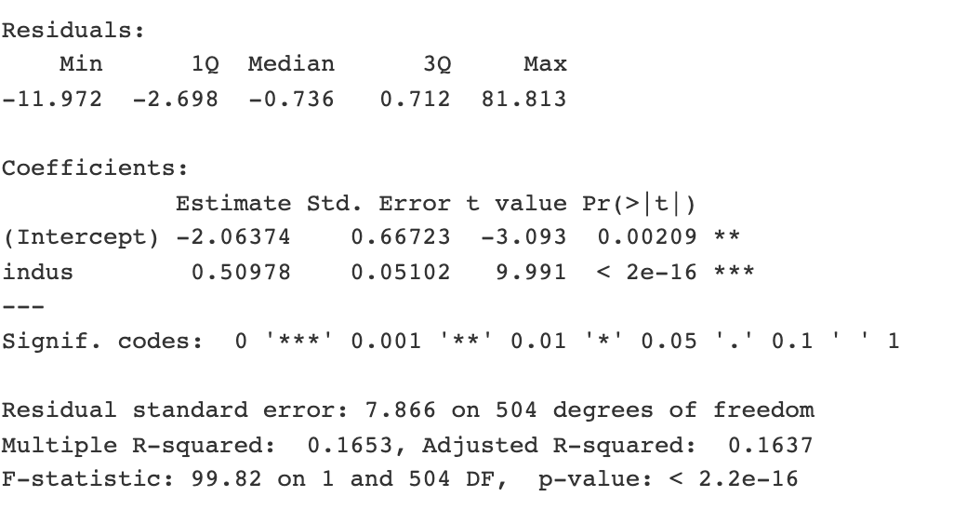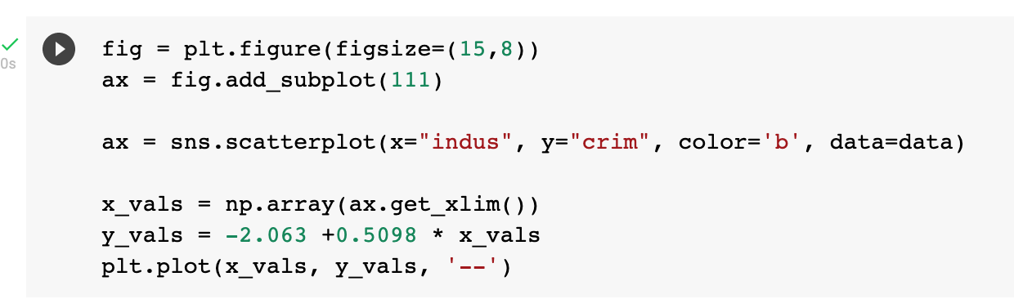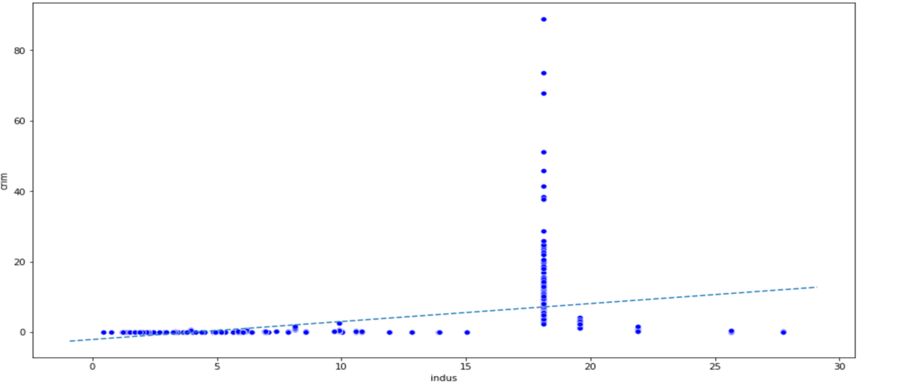

Its seen from the graph that there is a slightly positive relationship between the “crime” and “indus”

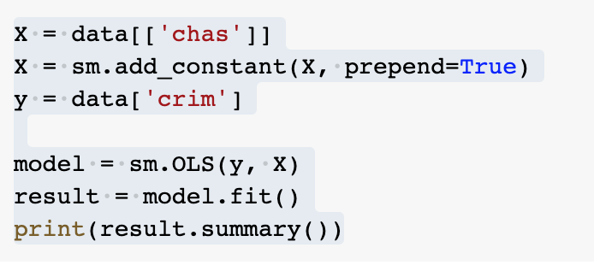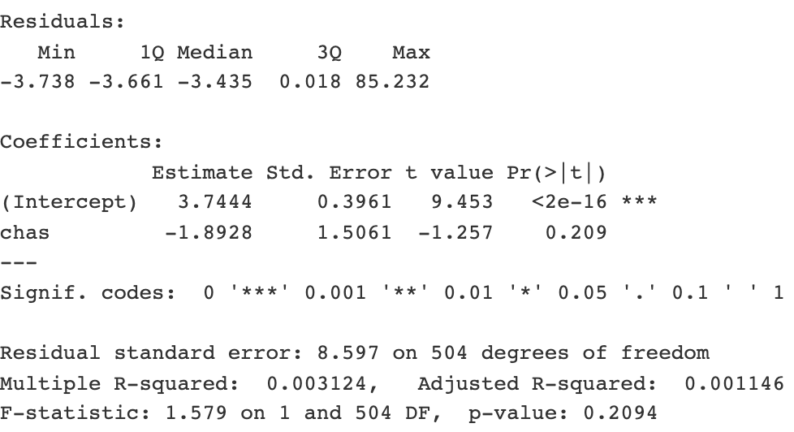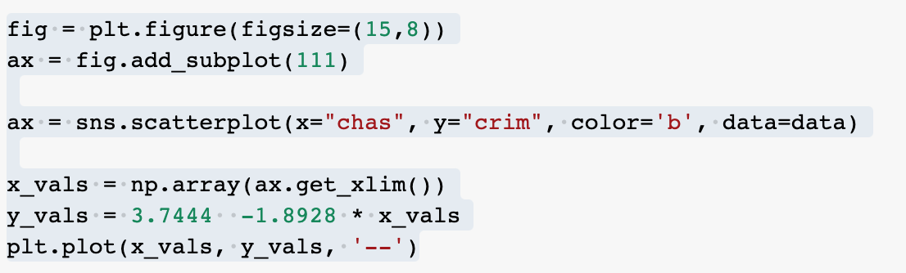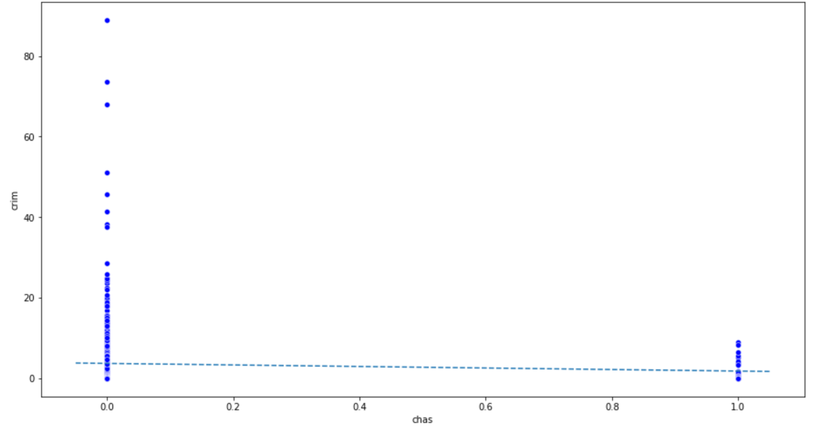

From the above graph we can say that changes in “chas” is not accompanied by an increase in the crime rate. Therefore there is no relationship between them

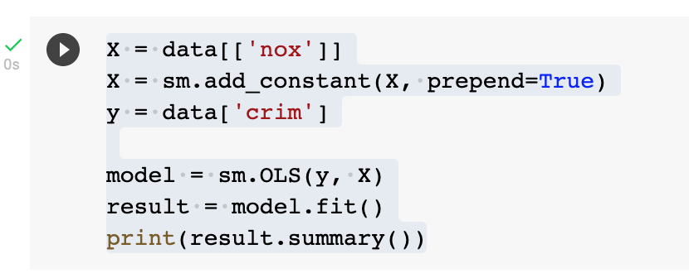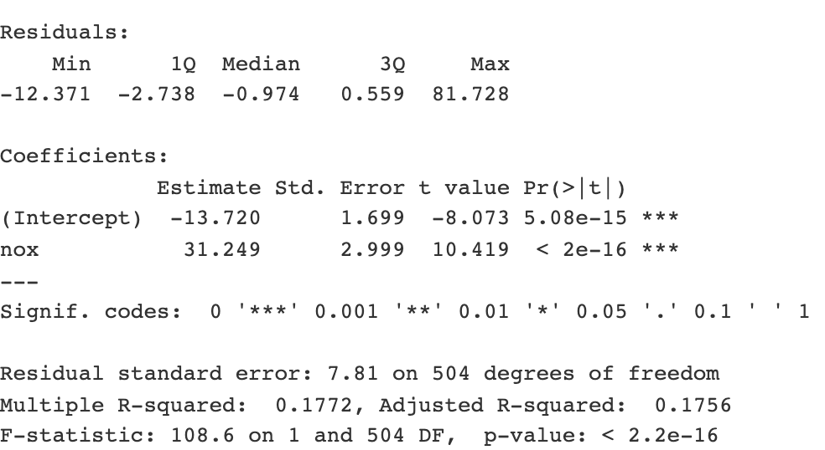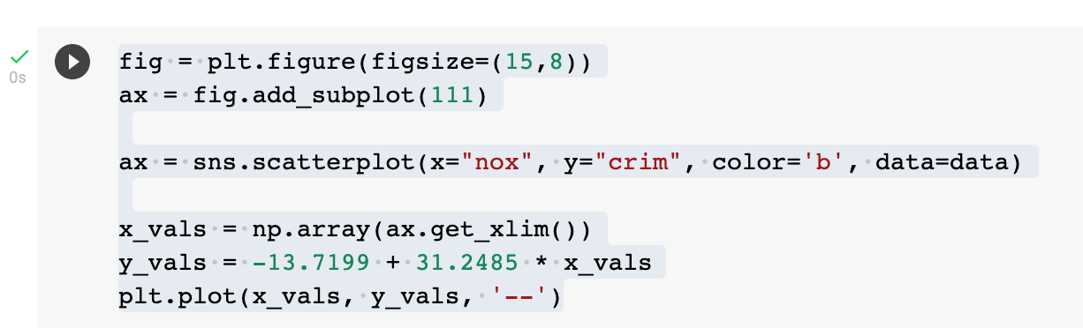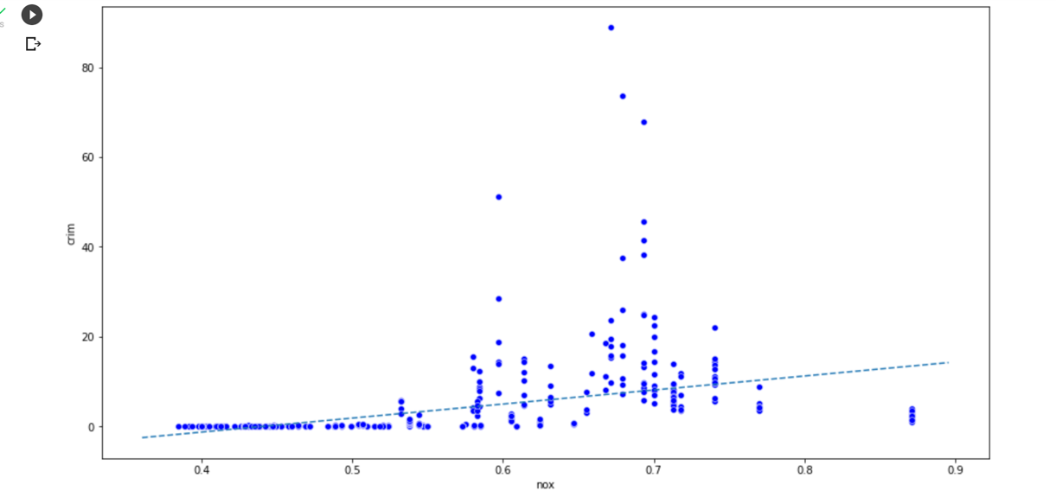

The above graph confirms that there exists a slightly lower positive correlation between crime and nitrogen oxides concentration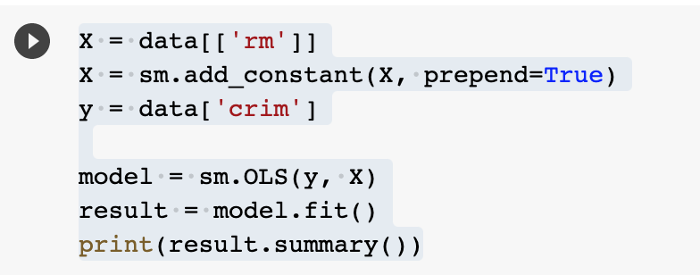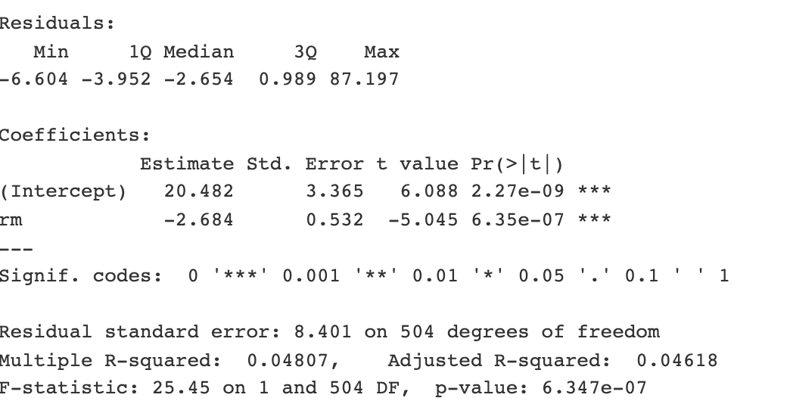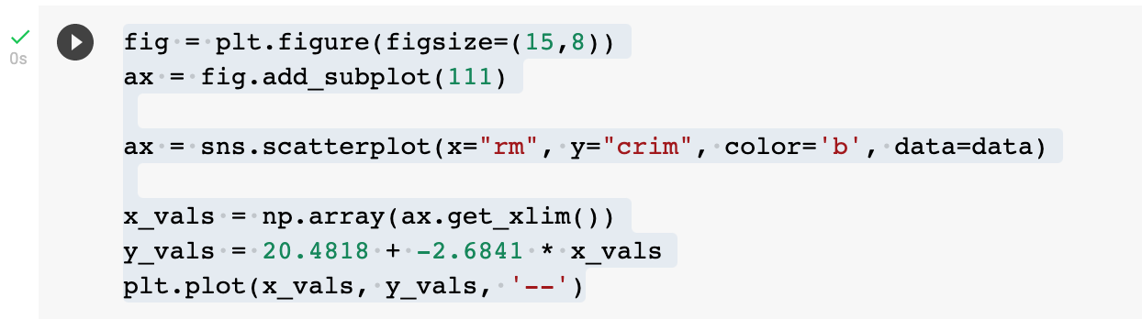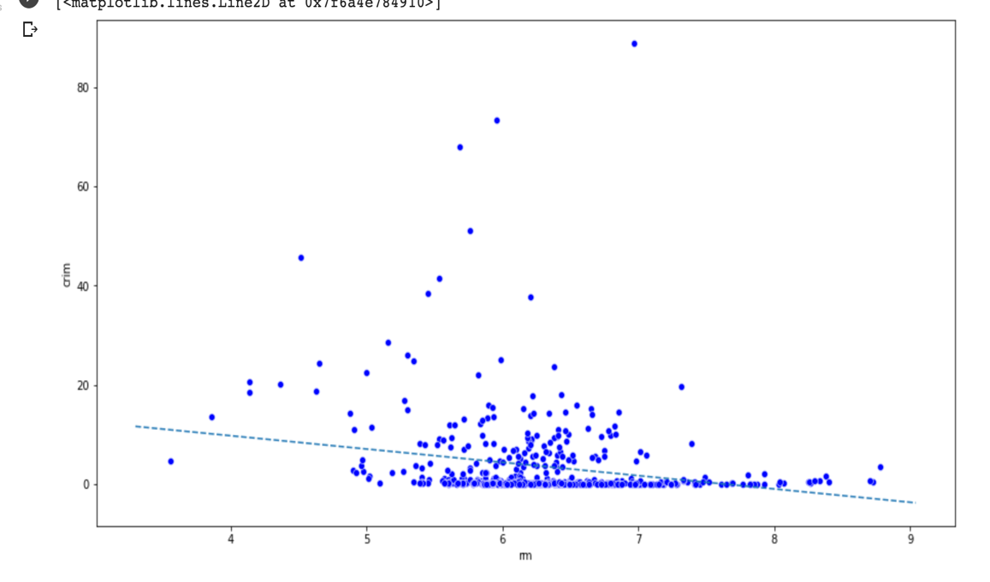

The graph shows the relationship between the crime rate and rm is defined by low sloping value.

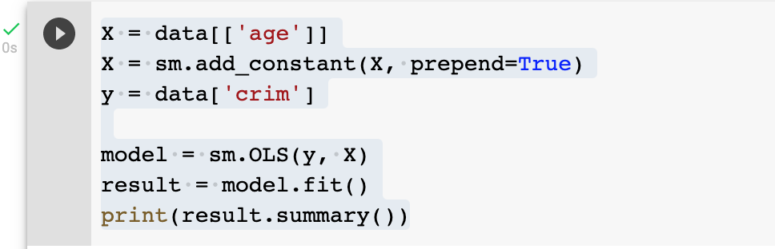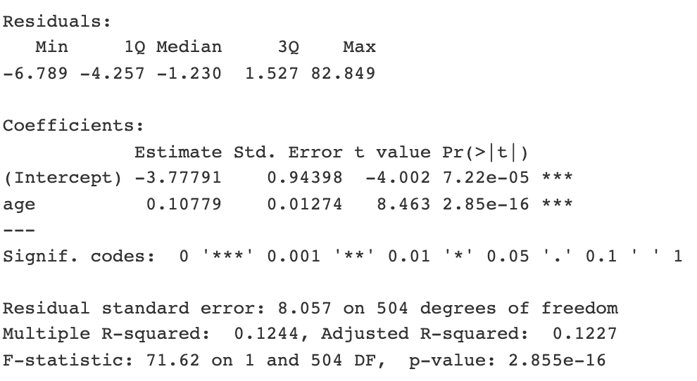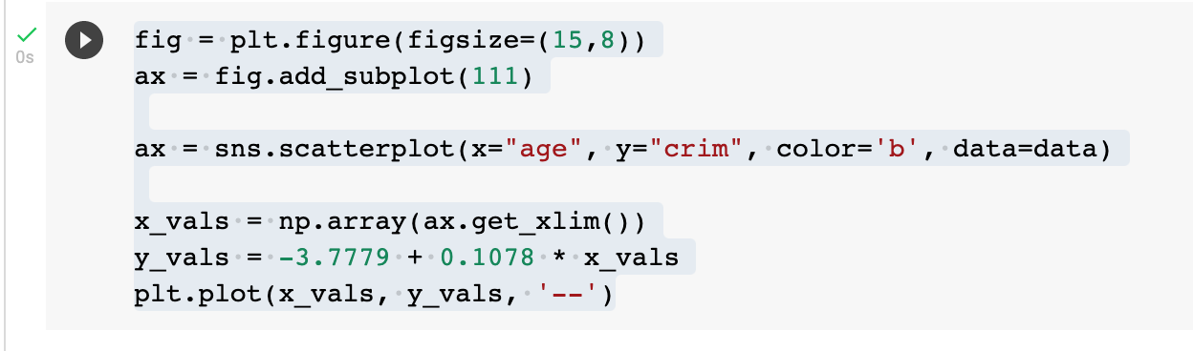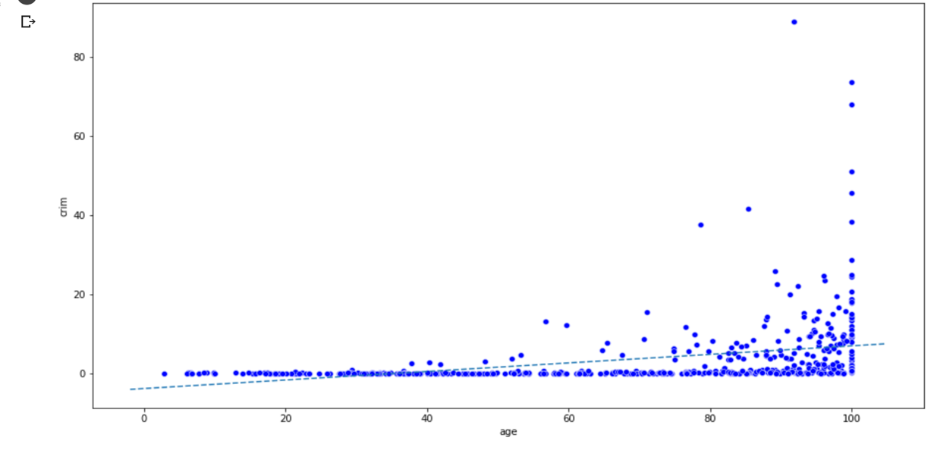

From the figure we can say there exists a low positive relationship between crime and age

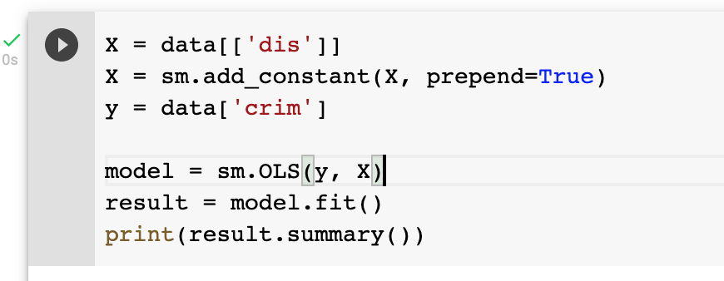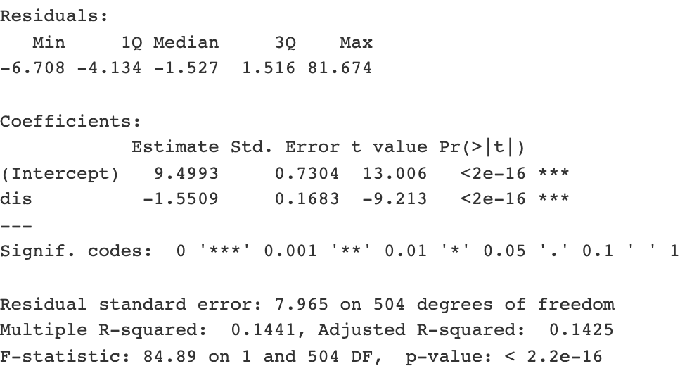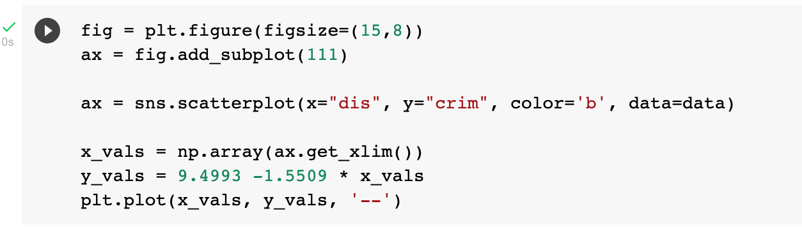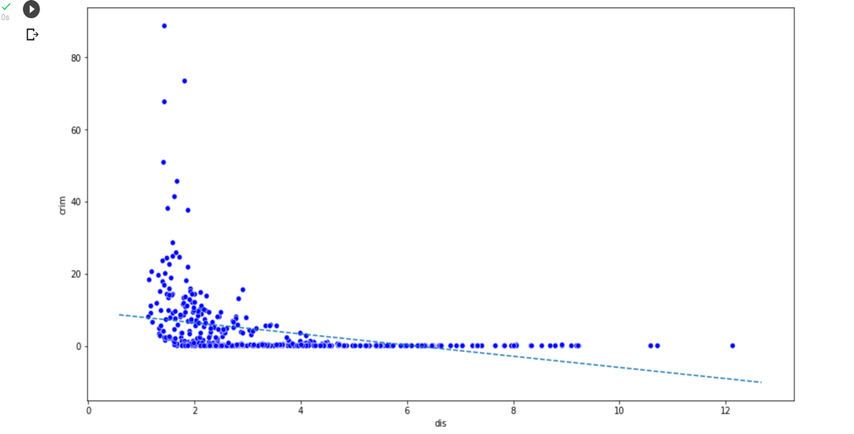

There is a low sloping relation between crime and dis

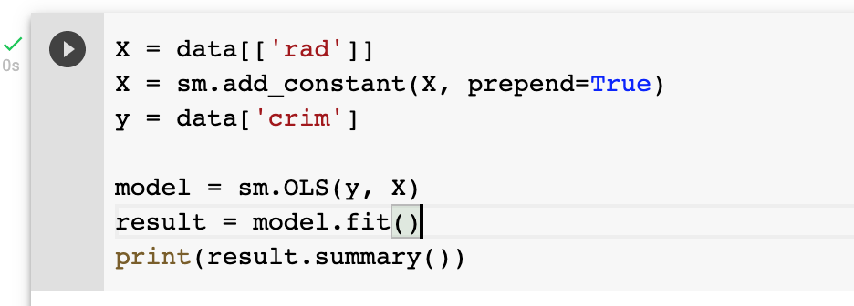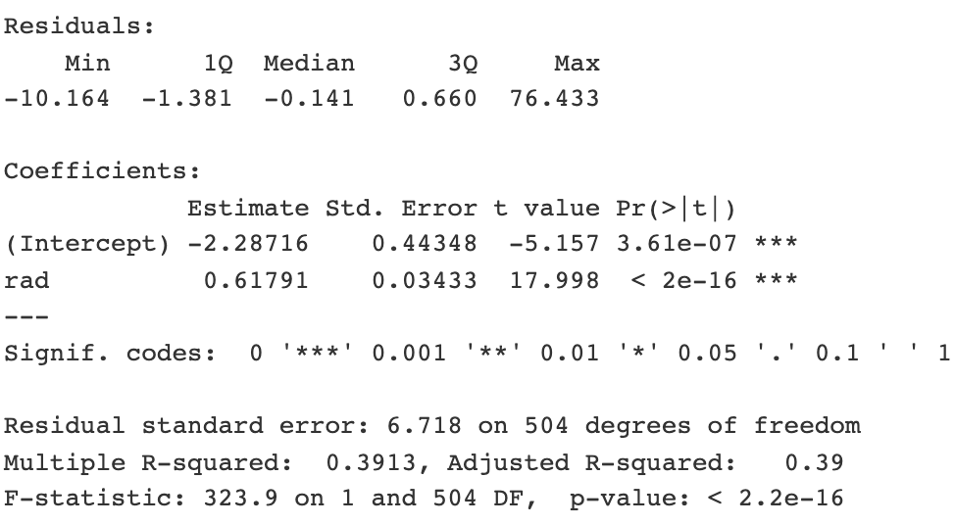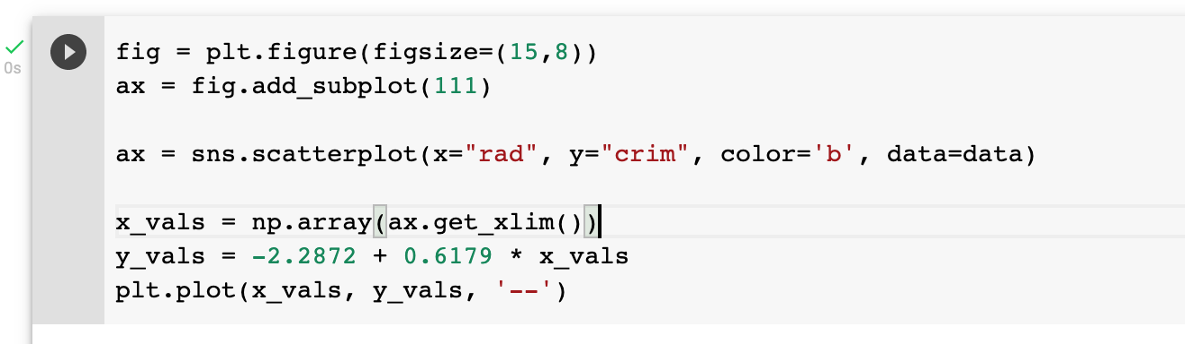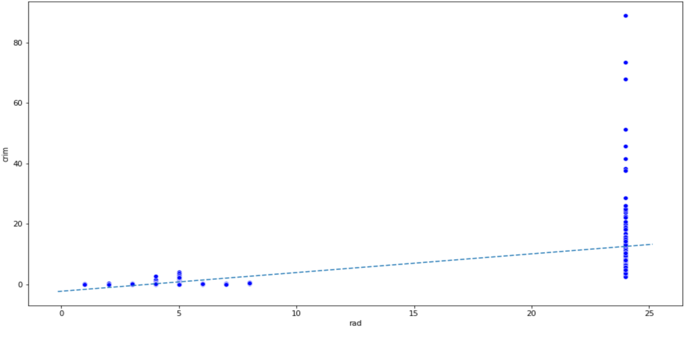

The graph confirms the existence of statistically significant relationship between crime and rad

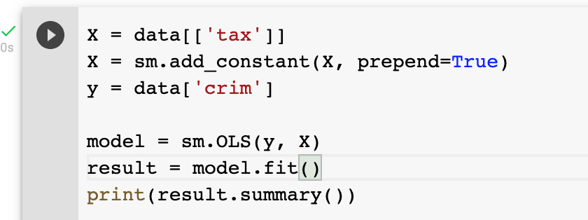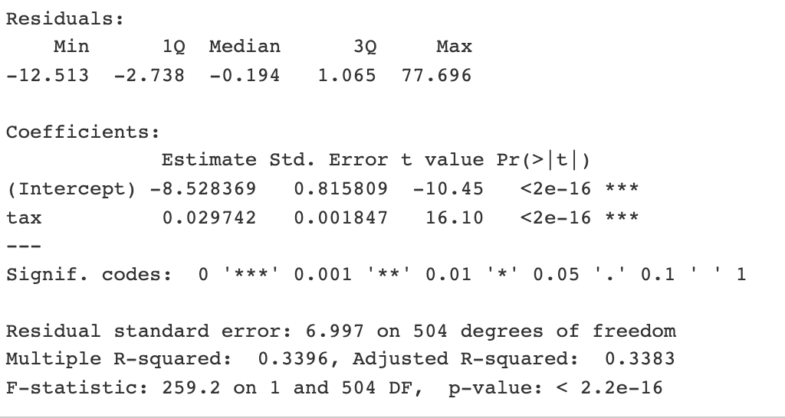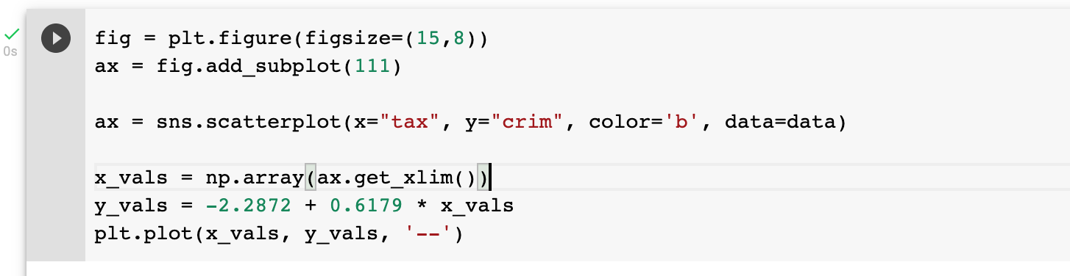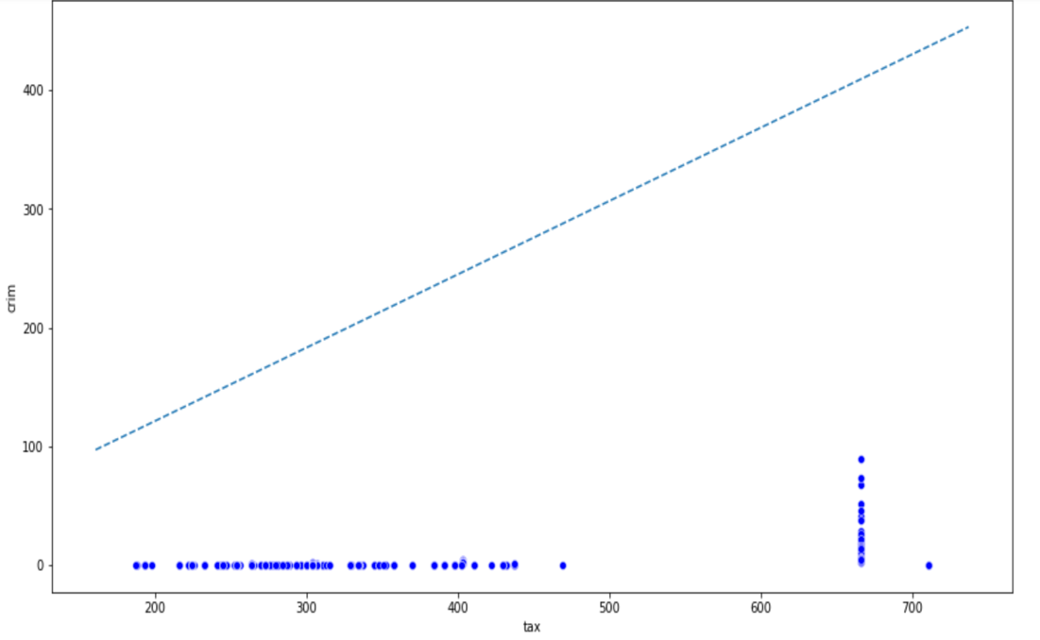

The graph above shows that there is a positive relationship between crime and tax

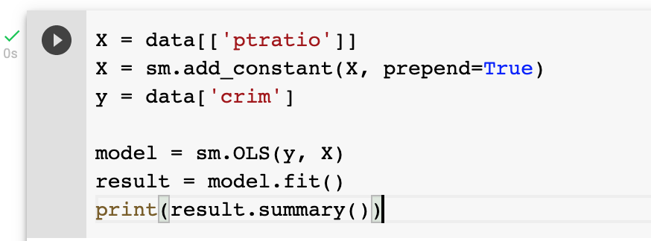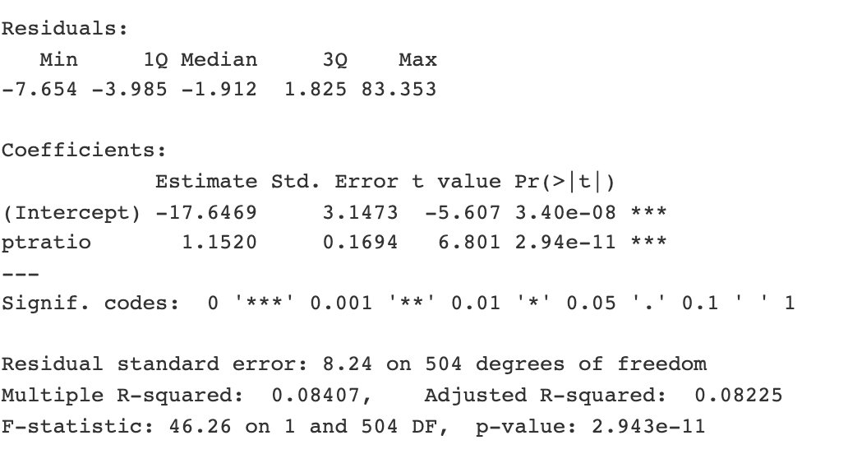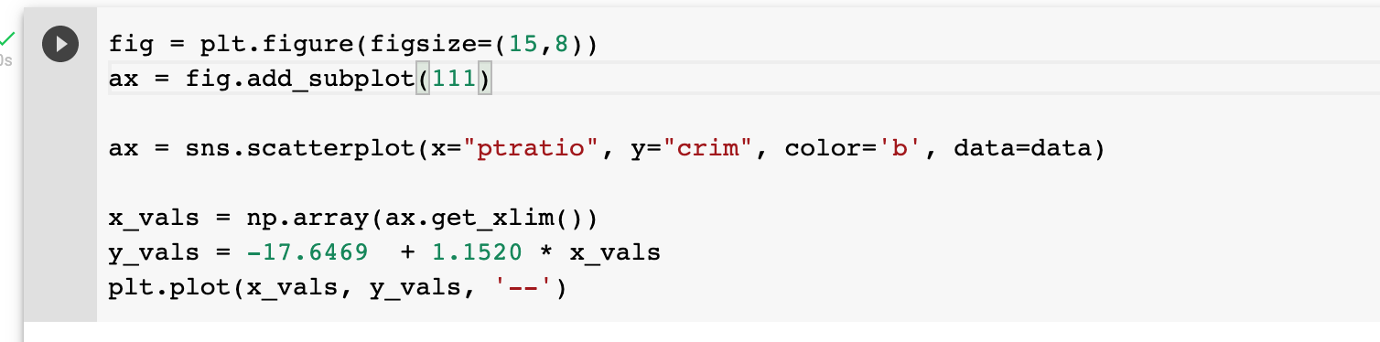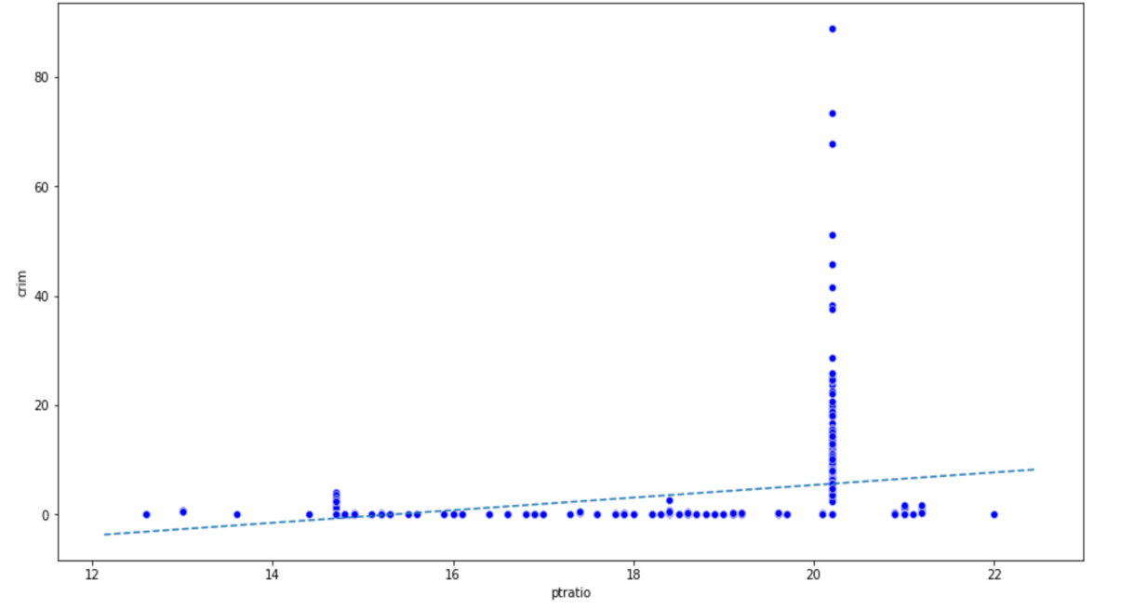

There is low positive correlation between ptratio and crime

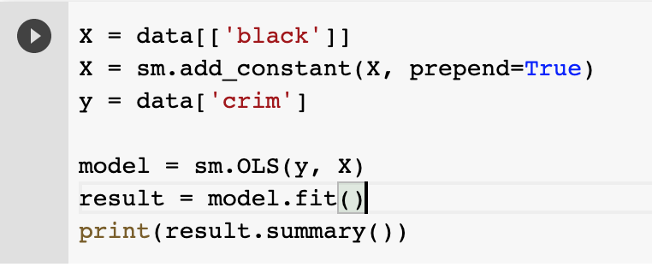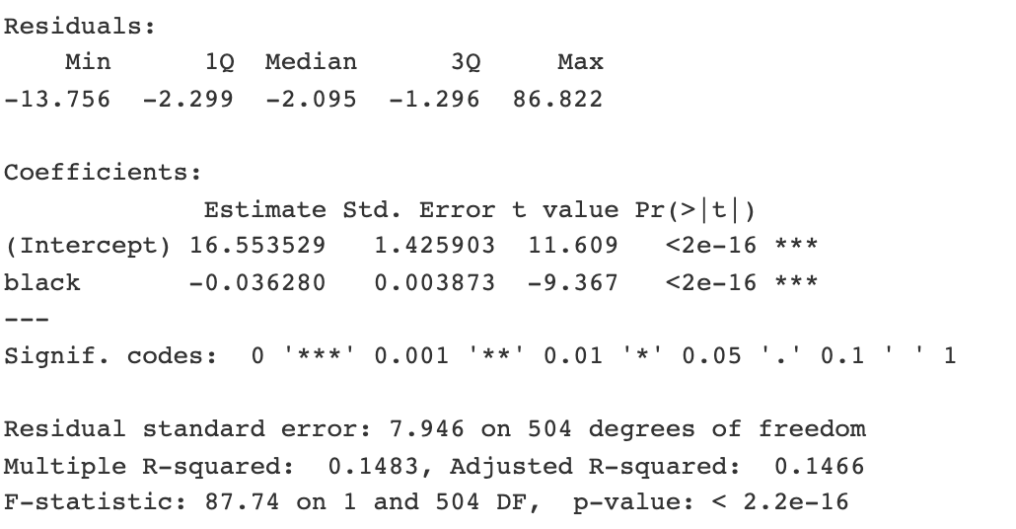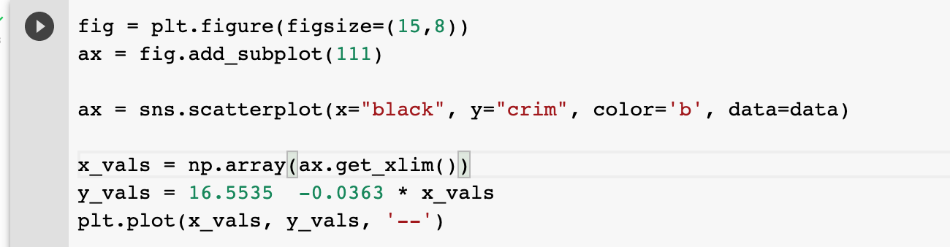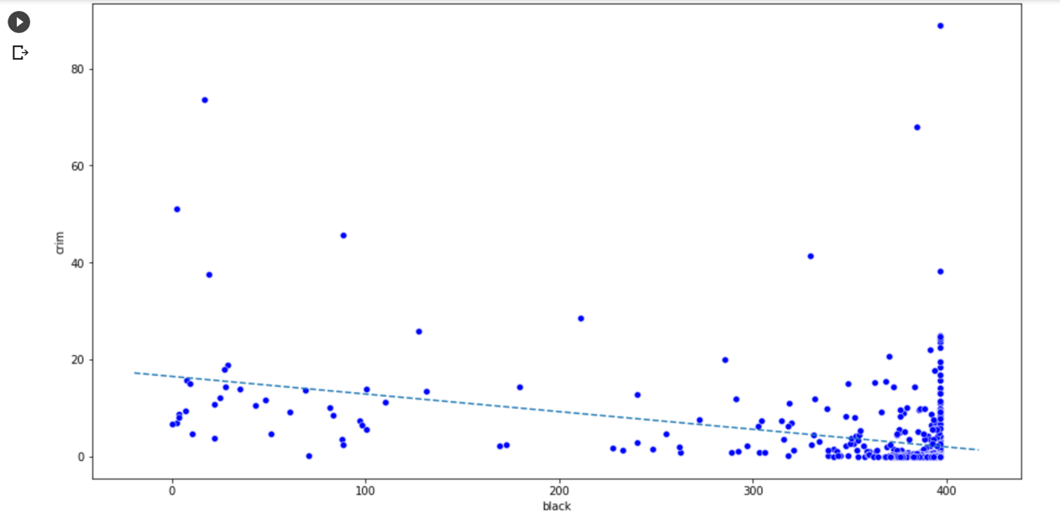

The graph confirms the statistical significant relationship between crime and black

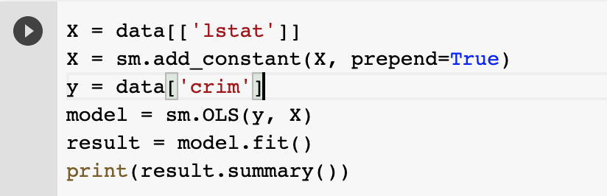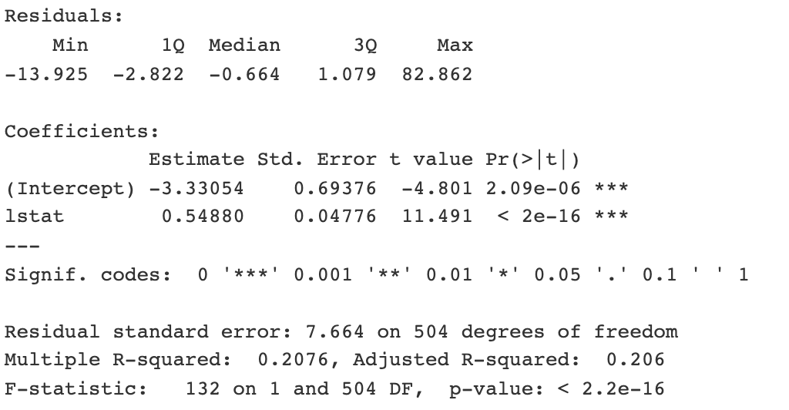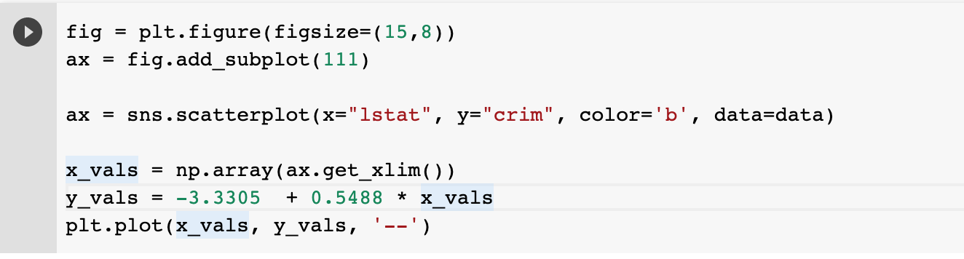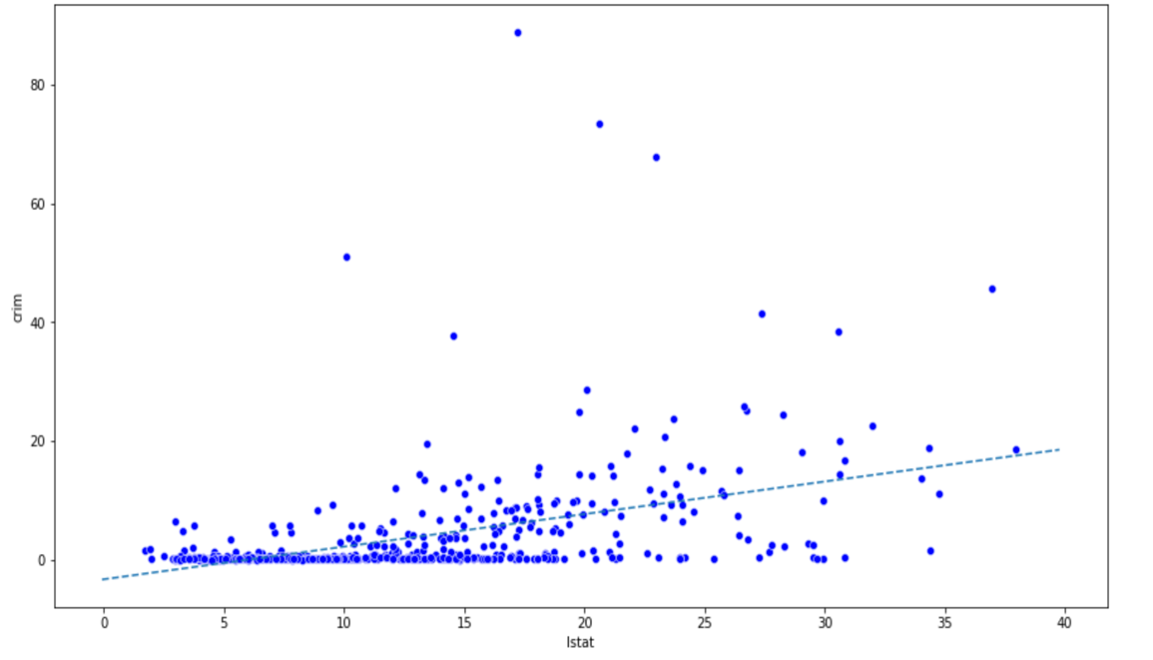

The graph shows that there is a statistical significant positive relation between crime and lstat

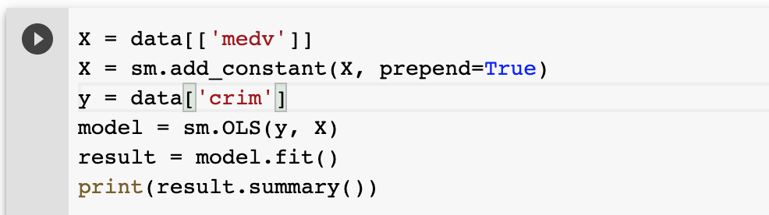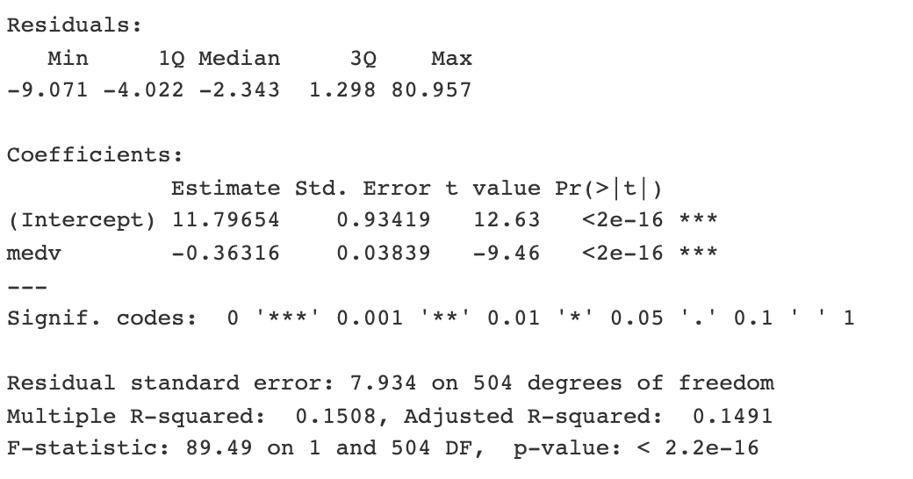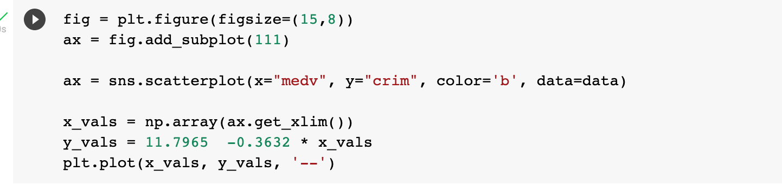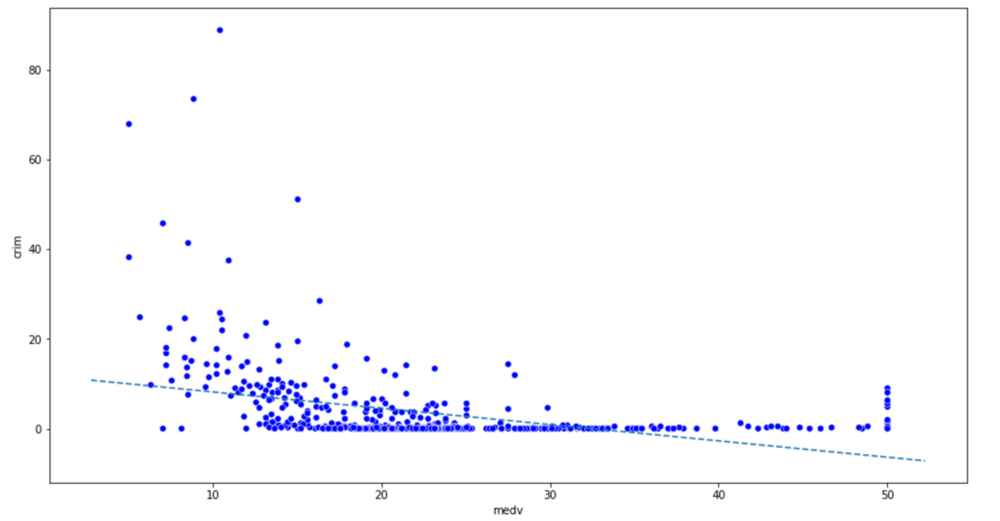

The relationship between medv and crime is slightly sloping as shown

In conclusion there is a statistically significant relationship between predictors and the response for every variable except chas The R squared and adjusted R squared values are very low for all the above models, and therefore these predictors describe a small amount of variation in crime response.

1. Fit a multiple regression model to predict the response using all of the predictors. De-scribe your results. For which predictors can we reject the null hypothesis H0:βj= 0?

Ans:

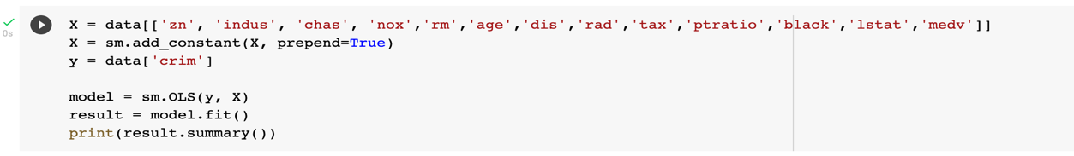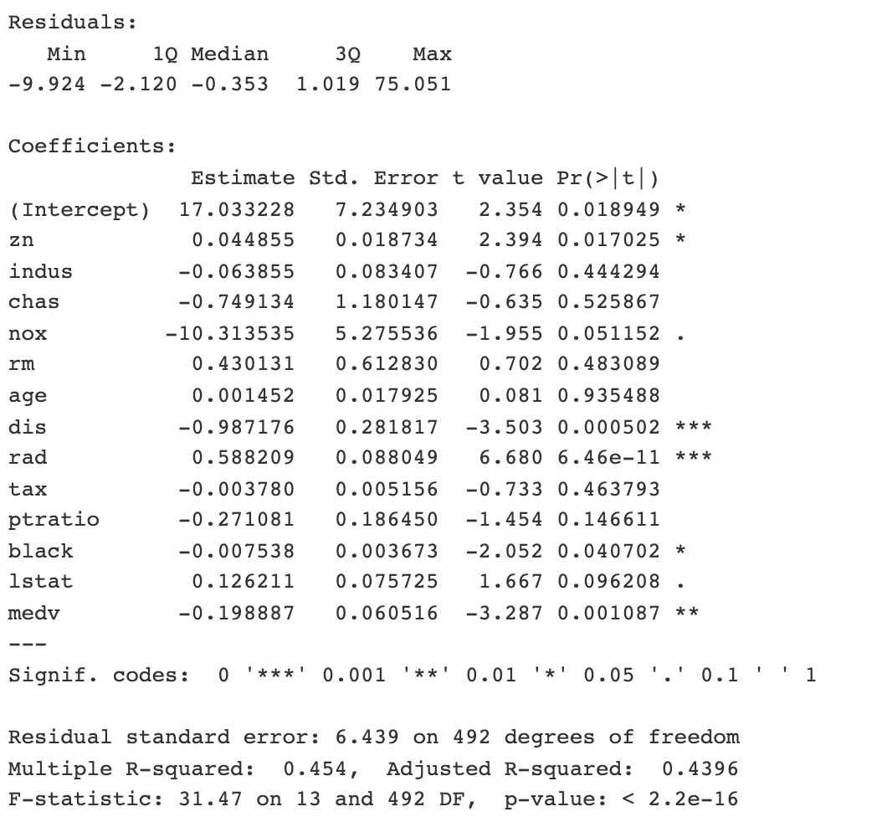

From the result obtained we can reject the null hypothesis of “zn”, “dis”, “rad”, “black”, “medv”. The multiple regression model generally does not fit Boston dataset very well because the R squared value is 0.45 and the adjusted R squared value is 0.43

1. (4 points) How do your results from (a) compare to your results from (b)? Create a plot displaying the univariate regression coefficients from (a) on the x-axis, and the multiple regression coefficients from (b) on they-axis. That is, each predictor is displayed as a single point in the plot. Its coefficient in a simple linear regression model is shown on the x-axis, and its coefficient estimate in the multiple linear regression model is shown on they-axis.

Ans: 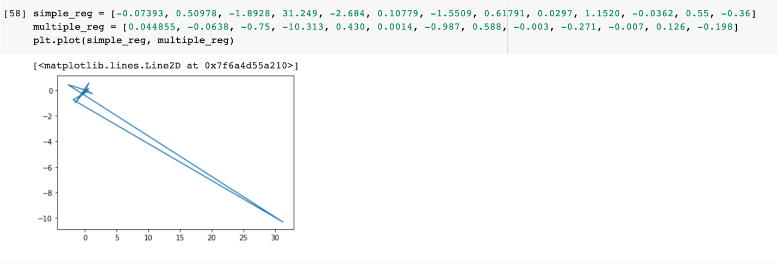

Univariate coefficients and multiple coefficients have distinct difference. This is because the slope of simple regression model represents the average effect of an increase in predictor ignoring the other predictors in the dataset. But the multiple regression holds other predictors fixed and its slope represents the average effect of an increase in the predictor.

1. 4 points) Is there evidence of non-linear association between any of the predictors and the response? To answer this question, for each predictor x, fit a model of the form y=β0+β1x+β2x2+β3x3+

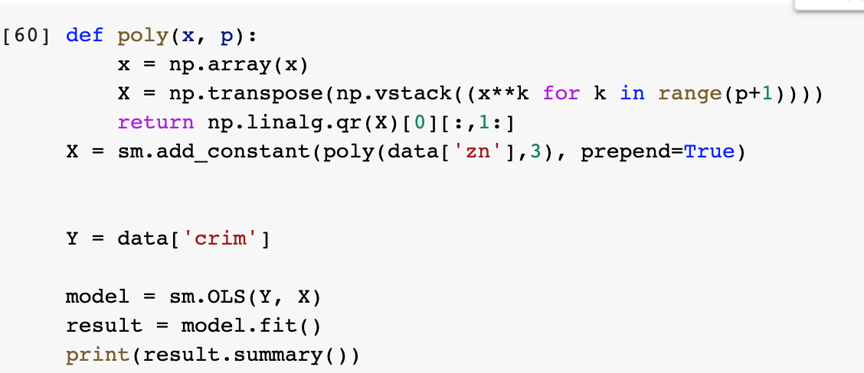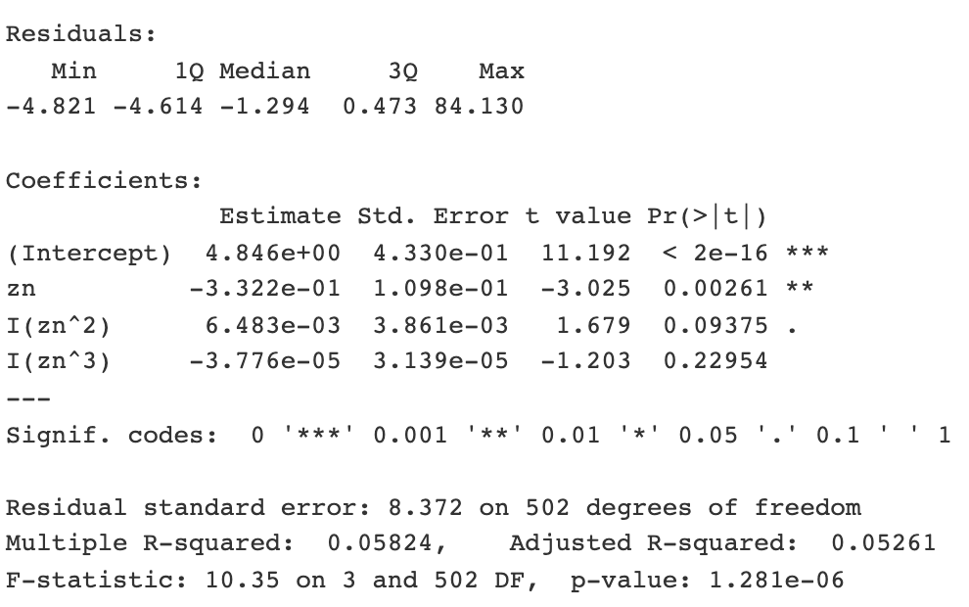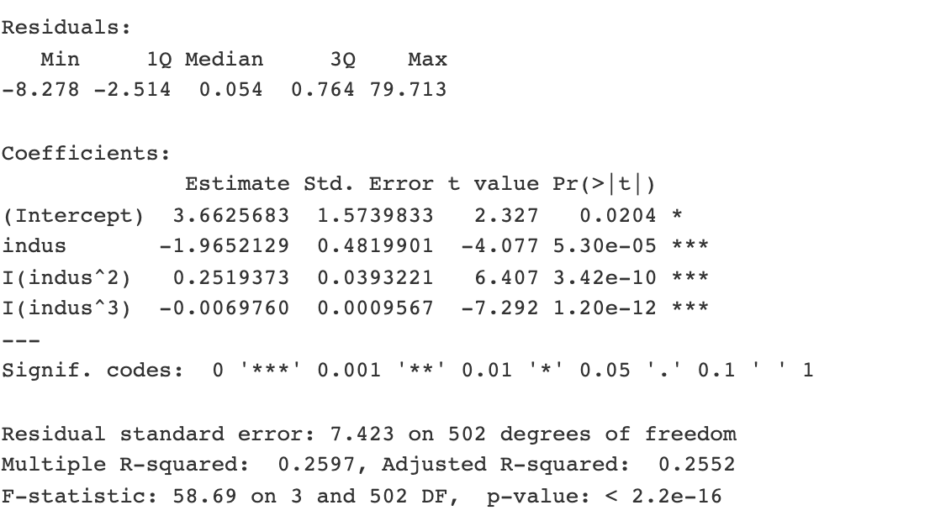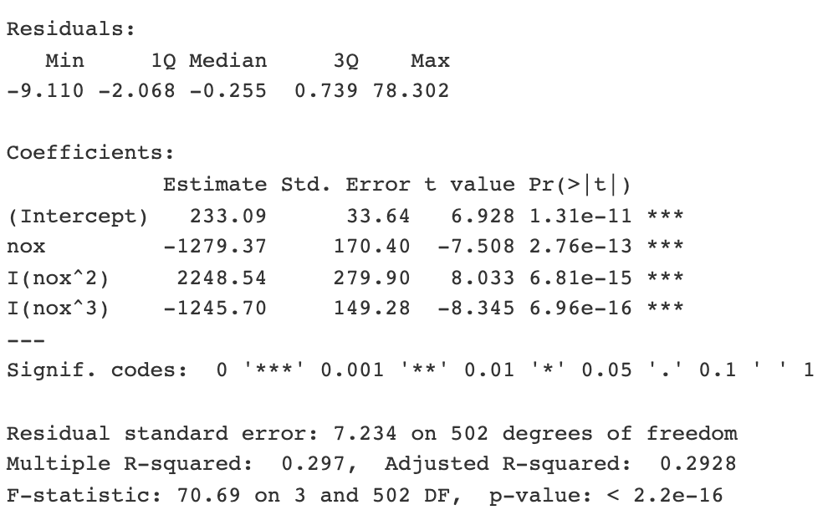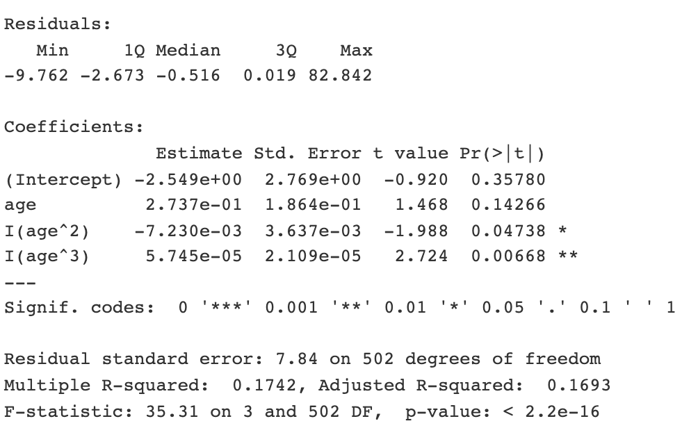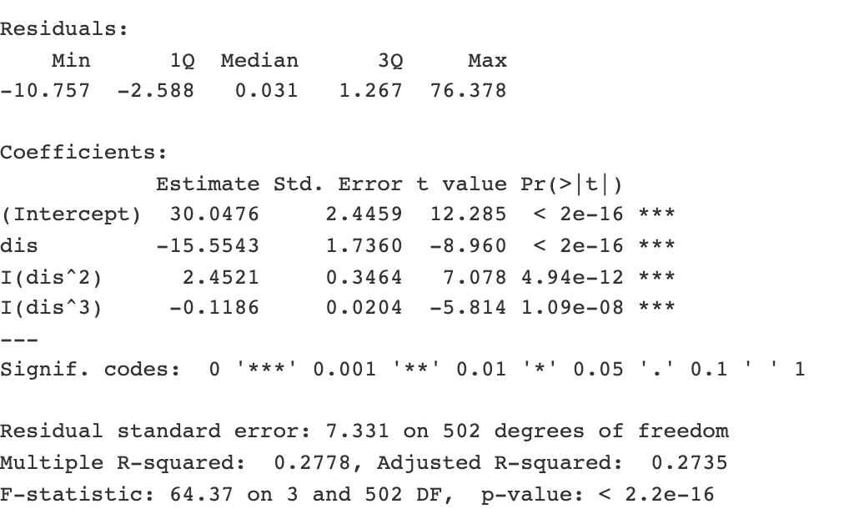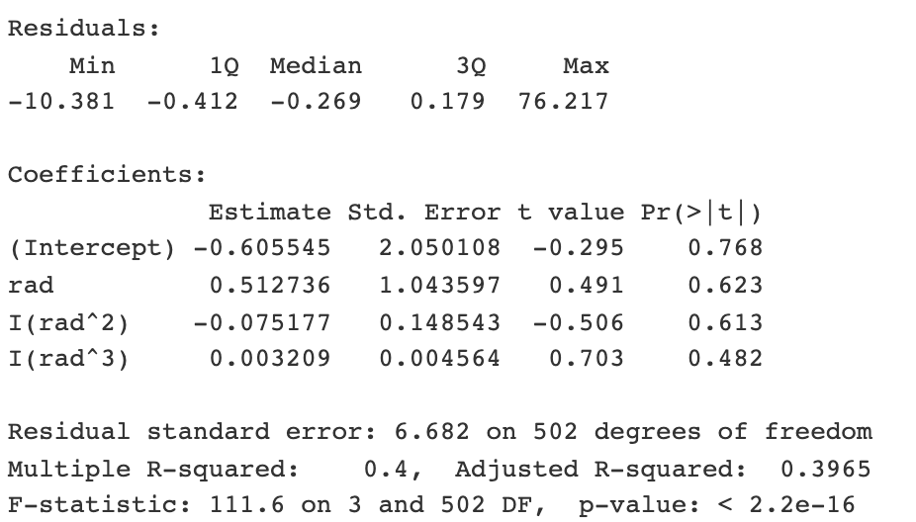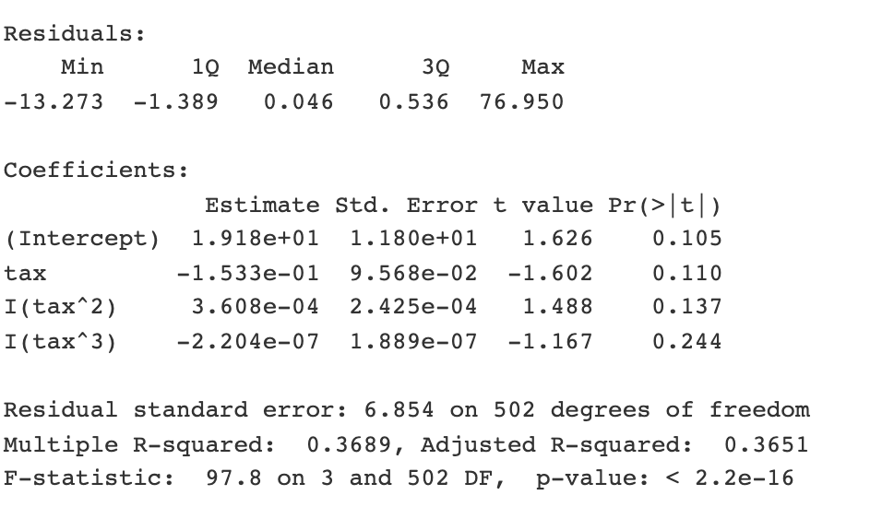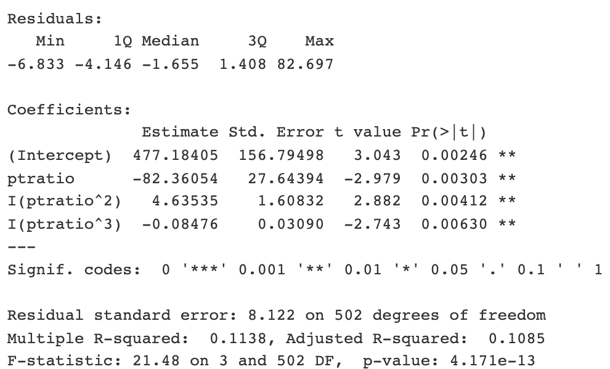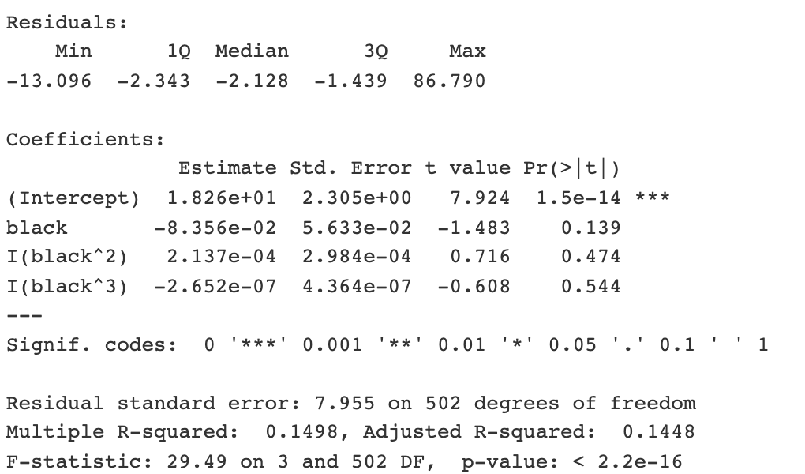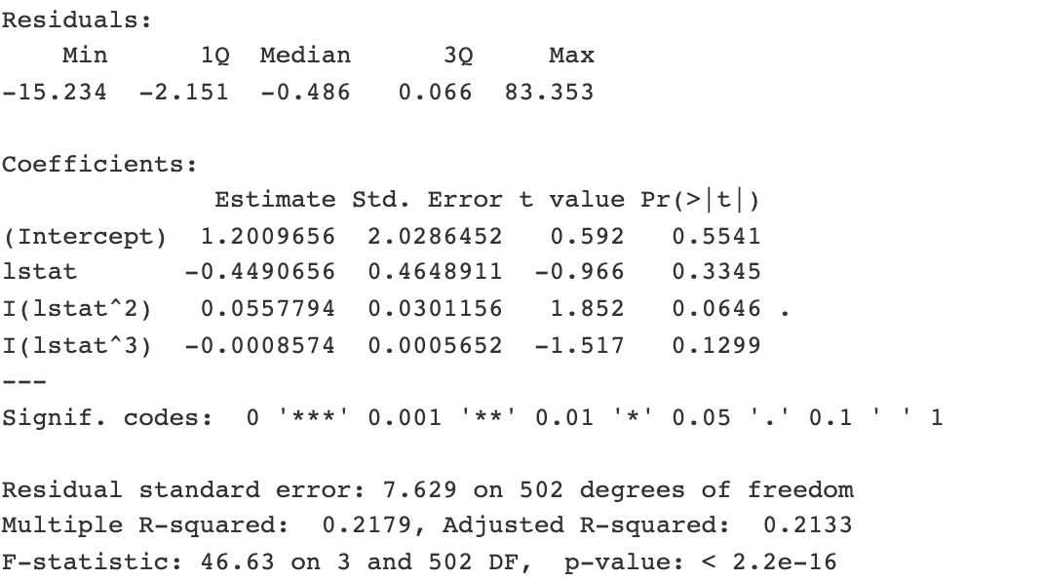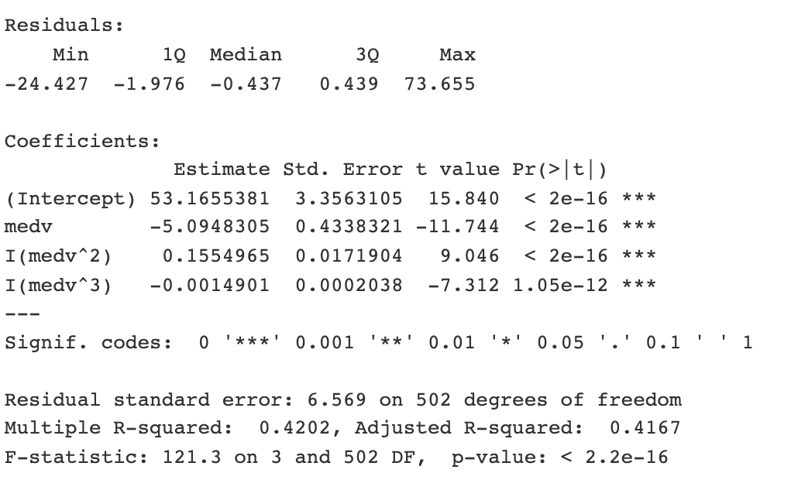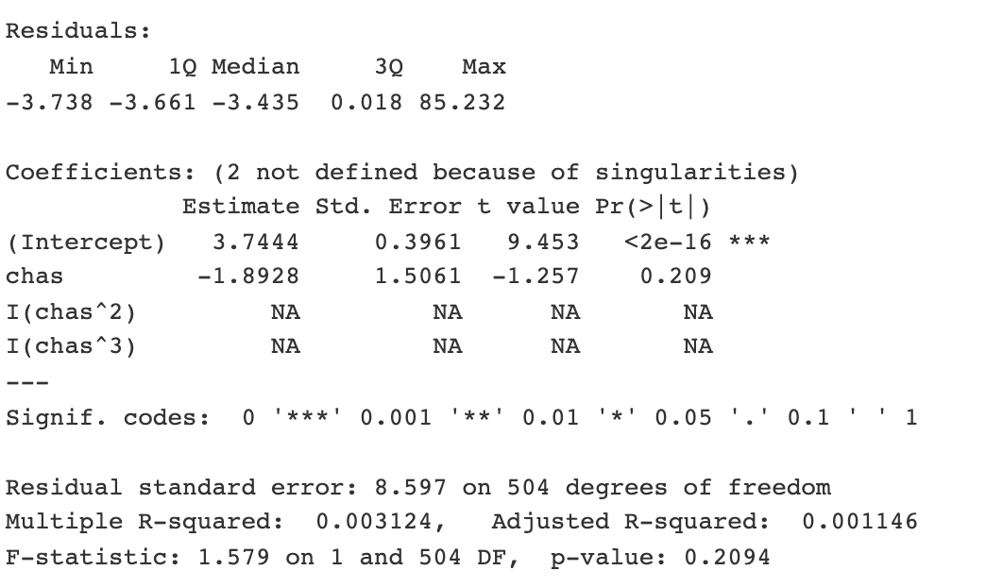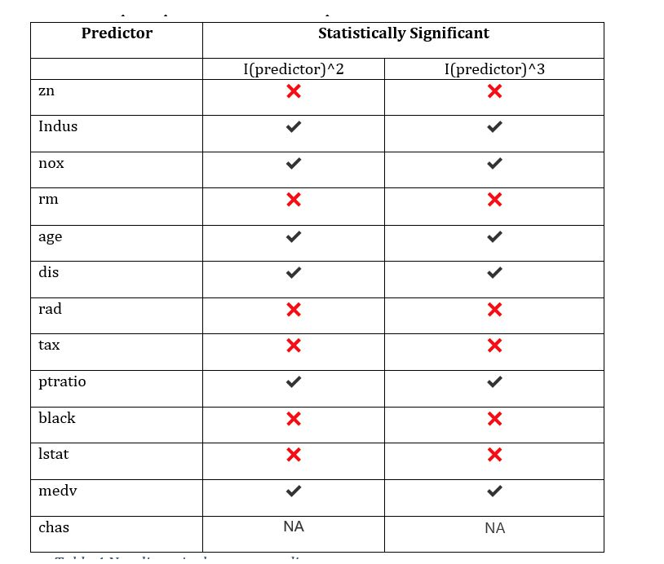

The table shows whether there is evidence of non-linear relationship between crime and predictors.